Patterns Around Us
Recognizes that patterns can be represented in different forms  “The description, equation, table, and graph all represent the same pattern.”  Start at 5 and add 4 each time.  y = 4x + 5  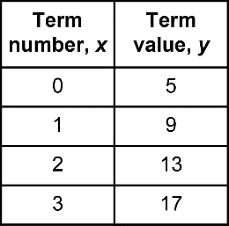  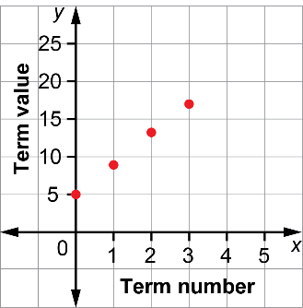 | Graphs patterns generated by  real-world scenarios  “Tom cycles 25 km each day to prepare for a cross-Canada trip.  My graph shows how far Tom cycles over the course of a week.”  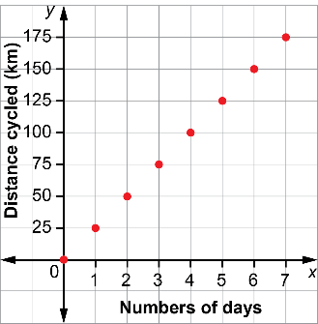 | Uses tables, graphs, and equations to model scenarios and solve problems  Tom has been told to cycle 750 km before the trip begins to get in shape. If he keeps cycling 25 km  a day, how long will it take?  “Tom cycles 25 km a day. So, an equation describing the distance cycled in x days is y = 25x. I need solve the equation 750 = 25x.  To do this, I divide both sides by 25;  x = 30. It will take 30 days for Tom  to cycle 750 km.” | Poses problems about scenarios that involve patterns  “What if Tom decides to cycle 35 km each day? How does the equation change? How many days would it take to cycle 750 km at this rate?  The new equation for distance cycled is y = 35x. Since Tom needs to cycle 750 km, I need to solve  750 = 35x. I divide both sides  by 35 and get x = 21.43.  This means that sometime on  day 22, Tom would reach 750 km.”

Observations/Documentation

