Determining Term Numbers and Term Values
Determines missing elements in linear and non-linear patterns  1, 2, __, 8, 16, 32, ___, 128  “I can see that each term is twice as great as the previous term. So, the missing terms are 4 and 64.” | Writes and uses an equation to determine pattern values  What is the value of this pattern when  x = 50?  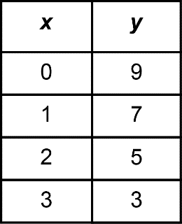  “An equation to represent this pattern is y = –2x + 9.  When x = 50,  –2x + 9 = –2(50) + 9  = –91  When x is 50, y is –91.” | Writes and uses an equation to determine a term number when term value is known  The equation y = –2x + 9 represents a pattern.  Which term in this pattern has a value of –41?  “I need to find a value of x so that  –41 = –2x + 9.  This means that –41 is 9 greater than –2x.  So, –41 – 9 = –2x, or –50 = –2x.  Using mental math, this is x = 25.” | Develops and uses linear equations to solve applied problems  Sky pays an annual gym membership fee of $50 and monthly fees of $25. Write an equation to describe the total cost. If Sky keeps their membership for 8 months, how much will they have spent?  “I’ll let the number of months Sky is a member be x. The total cost of membership is  y = 50 + 25x.  When x = 8,  y = 50 + 25(8)  = 50 + 200  = 250  Sky will pay $250 for 8 months of membership.”
Observations/Documentation

