Representing Linear Relations
Graphs a linear relation when given a table of values  “I drew a graph to show the data from this table.”  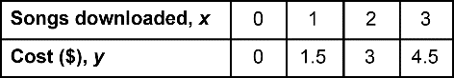  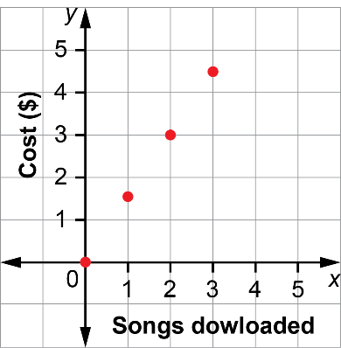 | Distinguishes situations involving discrete and continuous data  “I don’t need to join the points on my graph about costs to download songs because you can’t buy part of a song.” | Represents a linear relation in other forms when given one representation  “I was given a graph showing the cost of pizza slices. I identified ordered pairs for the points on the graph and made this table of values.  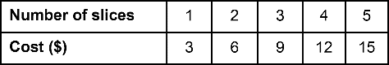  Every time you buy another slice, the price goes up by $3. An equation describing the cost of buying x slices is y = 3x. | Analyzes a linear relation and uses it to determine solutions to problems  An equation describing the cost of buying x slices is y = 3x.  By extending my table of values,  I can see that it would cost $21 to buy 7 slices of pizza.  By substituting in my equation,  I can see that it would cost $45 to buy 15 slices.
Observations/Documentation

