Writing Algebraic Pattern Rules
Writes a pattern rule given the relationship between the term number and term value  “If I know that the term value is 4 times the term number, plus 1, I can write the pattern rule 4x + 1 to describe the relationship.” | Writes an expression to represent a linear pattern  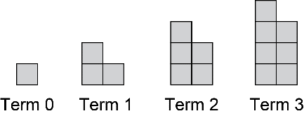  ”An expression that describes this pattern is 2n + 1 where n is the term number.” | Uses a pattern rule to determine values of terms  “When n = 50, the expression 2n + 1 is equal to  2(50) + 1 = 100 + 1  = 101  There would be 101 tiles in term 50. It is helpful to calculate this rather than trying to extend the pattern this far.” | Creates a pattern and writes an algebraic pattern rule to describe it  “My pattern is 100, 95, 90, 85,...  The numbers start at 100 and get 5 smaller with every term. I can describe any term value as 100 minus 5 times the term number. An expression for this is 100 – 5n.”
Observations/Documentation

