Exploring Patterns
Identifies increasing (growing) and decreasing (shrinking) patterns  Is this an increasing or decreasing pattern? What does this tell you about the graph of the pattern?  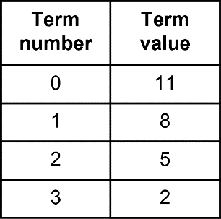  “When the term number increases, the term value decreases.  So, I know this is a decreasing pattern. As you move right on a graph, the points fall to the right.” | Identifies linear and non-linear patterns  “Every time the term number increases by 1, the term value decreases by 3. So, the pattern has a constant rate. This means it is linear. I know the graph will be a series of points that lie along a straight line.” | Determines rate of change and initial value of a linear pattern  What is the constant rate for the pattern y = –2x + 5? What is its initial value?  “I’m not certain, so I’m going to make a table of values.  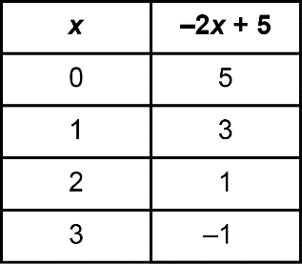  From my table, the constant rate is  –2 and the initial value is 5. I see they match the coefficient of the variable and the constant term.” | Predicts the effect of changing the coefficient of the variable or the constant in a pattern rule  How is the graph of y = x + 5 the same as the graph of y = –2x + 5? How is it different?  “Both graphs are straight lines that pass through (0, 5). The graph of y = x + 5 slopes up to the right  and is less steep than the graph  of y = –2x + 5, which slopes down  to the right.”
Observations/Documentation

