Determining Elements
in Linear Patterns
Algebra
Unit 1 Line Master 5a

Choose two of these four patterns and answer the questions.

A.  The term value is the number of toothpicks.  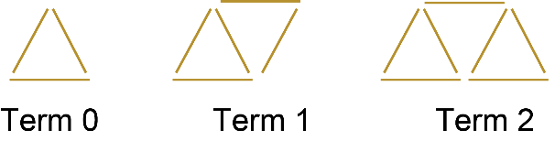 | B.  This number pattern starts with term 0  −10, −7, −4, −1, 2, …
C.  x y  1 3.5  2 6  3 8.5  4 11  5 13.5 | D.  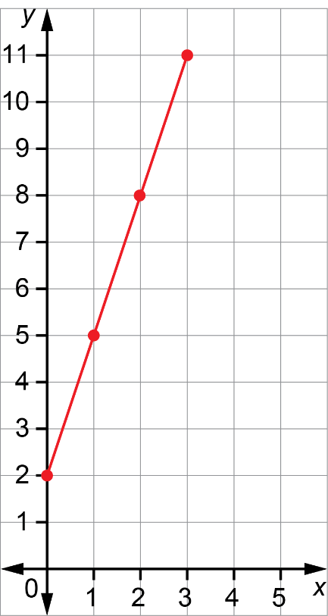

Determining Elements
in Linear Patterns (cont’d)
Algebra
Unit 1 Line Master 5b

My first pattern is _____.

1. Write an equation to describe this pattern.
Explain how you wrote it.

2. What is the value of term 8? Show your work.

3. What is the value of term 15? Show your work.

4. What is the number of the term with a value of 41?
Explain how you know.

Determining Elements
in Linear Patterns (cont’d)
Algebra
Unit 1 Line Master 5c

My second pattern is _____.

5. Write an equation to describe this pattern.
Explain how you wrote it.

6. What is the value of term 8? Show your work.

7. What is the value of term 15? Show your work.

8. What is the number of the term with a value of 41?
Explain how you know.

