Analyzing a Linear Relation
Algebra
Unit 1 Line Master 4a

x | y
–3
–2
–1
0
1
2
Start with the relation y = 3x – 4, where x is any number.
1. Determine the values of y that complete
the table of values.

2. Record the information from the table
as a series of ordered pairs.

3. Graph the ordered pairs and join them
with a line.
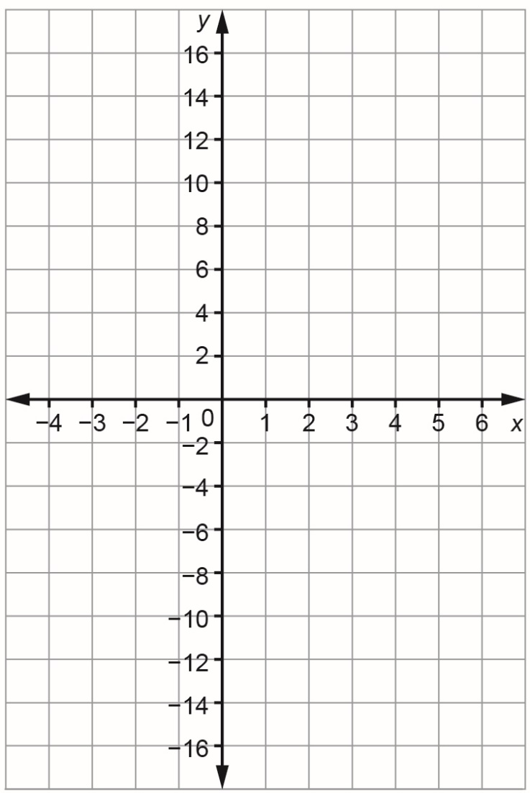
Analyzing a Linear Relation (cont’d)
Algebra
Unit 1 Line Master 4b

4. Why can you join the points on the graph with a line?

5. Is this an increasing or decreasing relation?
Explain how you know.

Analyzing a Linear Relation (cont’d)
Algebra
Unit 1 Line Master 4c

6. What is the value of y when x is 6?
How can you determine the answer using the graph?
How can you determine the answer using the equation?

7. Does the point (4, 9) lie on the graph?
How do you know?

