Fencing a Garden
Algebra
Unit 1 Line Master 3a

This graph shows the relationship between the side length
of a square garden and the perimeter.
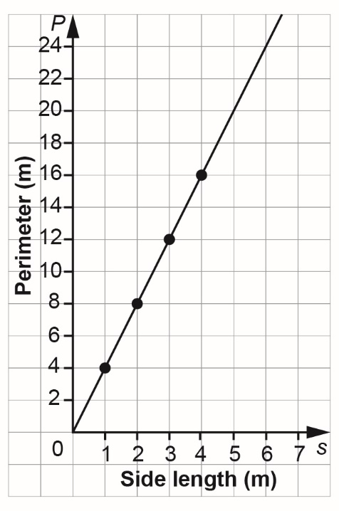
s | P
0
1
2
3
4
1. a) Complete the table of values
for the relationship.

b) What does s represent?

c) What does P represent?

Fencing a Garden (cont’d)
Algebra
Unit 1 Line Master 3b

2. Why are the points on the graph joined by a line?

3. Write an equation to describe the relationship in the graph
and table.

4. How much fencing material would a person need to fence
a square garden with sides 6 m long?
How did you determine your answer?

Fencing a Garden (cont’d)
Algebra
Unit 1 Line Master 3c

5. Suppose a person has 20 m of fencing.
What is the side length of the largest square garden
they could enclose?
How did you determine your answer?

6. Suppose a person has 14 m of fencing.
What is the side length of the largest square garden they could
enclose if the side length does not need to be a whole number
of metres?

