Writing Algebraic Pattern Rules
Algebra
Unit 1 Line Master 2

Pattern image or description | Pattern rule and value,  when n = 6 and when n = 10
The number of squares in term n
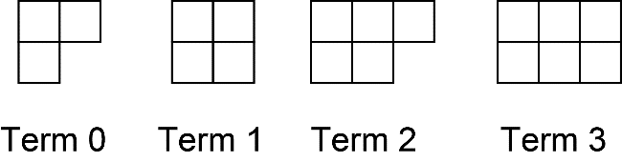
The term value is 5 more than the product of the term number, n,
and 4.5
The number of squares in term n
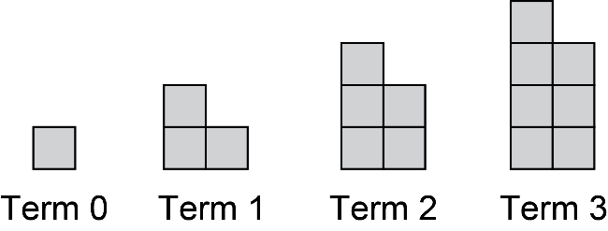
The value of term n in this pattern that starts with term 0
5, 1, –3, –7,...
The term value is 4 times the term number, n, subtracted from 16
The value of term n in this pattern that starts with term 0
4, $\frac{7}{2}$, 3, $\frac{5}{2}$, ...

