Comparing Linear Patterns
Algebra
Unit 1 Line Master 1a

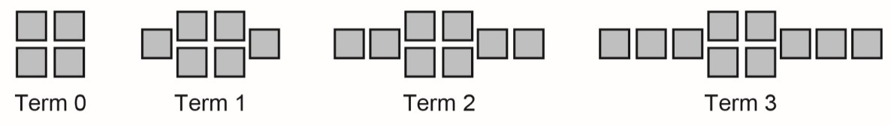
1. a) Each pattern is shown as an expression and in another form.
Complete the table of values for pattern B.
Add graphs of patterns B and C to the graph of pattern A.
B: 2x + 4

Term number, x | Term value, y
0
1
2
3

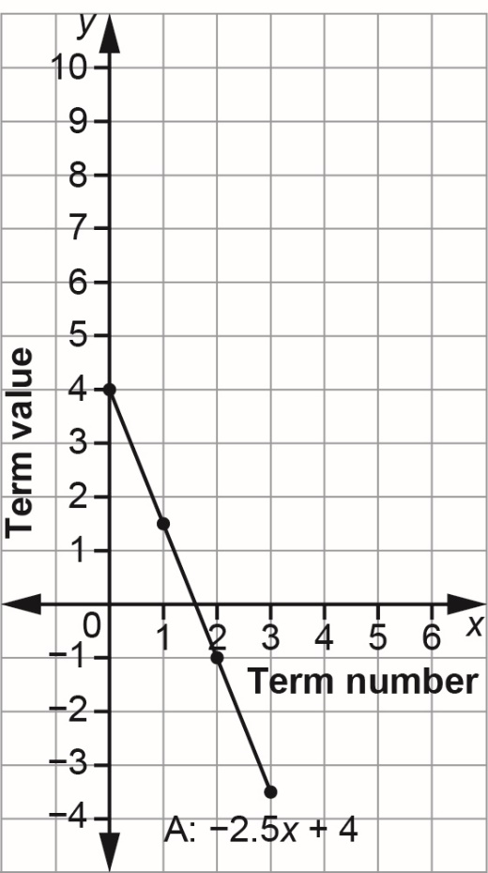

C: –x + 4
x | –x + 4
0 | 4
1 | 3
2 | 2
3 | 1

Comparing Linear Patterns (cont’d)
Algebra
Unit 1 Line Master 1b

b) How do the expressions compare?
How do the graphs compare?

2. a) Each expression represents a pattern.
For each pattern, complete the table.
A: –2x B: –2x + 2
x | –2x
0
1
2
3
x | –2x + 2
0
1
2
3

C: –2x + 4
x | –2x + 4
0
1
2
3

Comparing Linear Patterns (cont’d)
Algebra
Unit 1 Line Master 1c

b) Graph each pattern on the grid provided on the next page. You can join each set of points with a line.
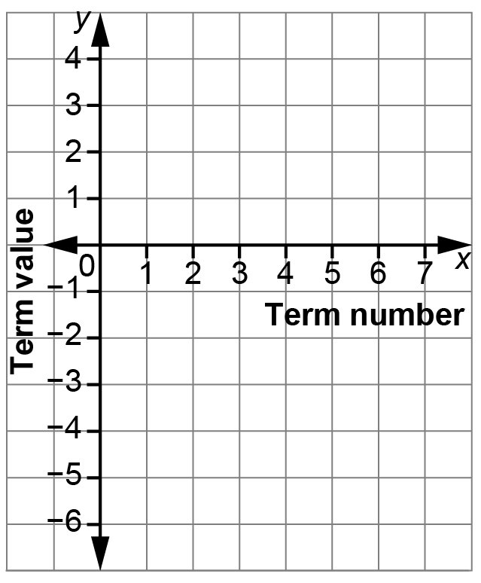

c) How do the expressions compare?
How do the lines on the graph compare?

