Answers
Algebra
Unit 1 Line Master 1d

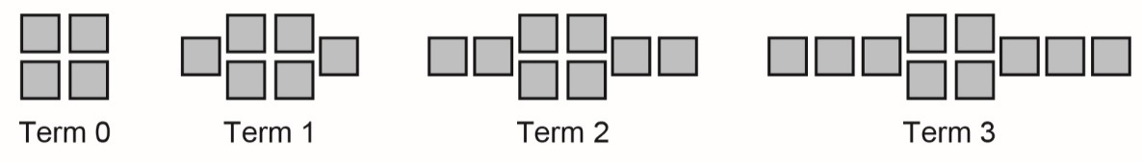
1. a) Each pattern is shown as an expression and in another form.
Complete the table of values for pattern B.
Add graphs of patterns B and C to the graph of pattern A.
B: 2x + 4

Term number, x | Term value, y
0 | 4
1 | 6
2 | 8
3 | 10

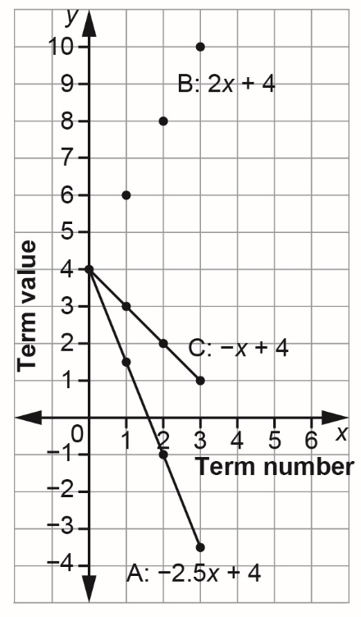

C: –x + 4
x | –x + 4
0 | 4
1 | 3
2 | 2
3 | 1

Answers (cont’d)
Algebra
Unit 1 Line Master 1e

b) How do the expressions compare?
How do the graphs compare?
Each expression has a constant term of 4.
They all have different coefficients of x.
The graphs all have the same initial point (0, 4).
Two of the graphs are straight lines that slope down to the right.
The graph of Pattern B is a series of dots that lie along
a straight line that slopes up to the right.
2. a) Each expression represents a pattern.
For each pattern, complete the table.
A: –2x B: –2x + 2
x | –2x
0 | 0
1 | −2
2 | −4
3 | −6
x | –2x + 2
0 | 2
1 | 0
2 | −2
3 | −4

C: –2x + 4
x | –2x + 4
0 | 4
1 | 2
2 | 0
3 | −2

Answers (cont’d)
Algebra
Unit 1 Line Master 1f

b) Graph each pattern on the grid provided on the next page.
You can join each set of points with a line.
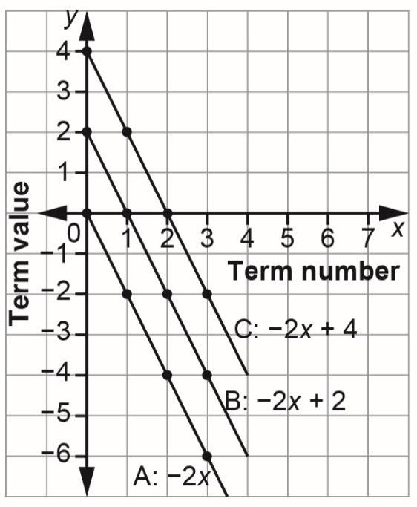

b) How do the expressions compare?
How do the lines on the graph compare?
Each expression has a different constant term.
They all have the same coefficient of x, which is –2.
The graphs all have different initial points.
All the graphs are straight lines that slope down to the right
and have the same steepness. They are parallel.

