Solving Equations Involving the Distributive Property
Uses algebra tiles to represent an equation of the form a(x + b) = c  I used tiles to model 3(x – 1) = –9.  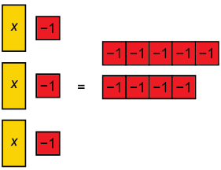 | Rewrites an equation of the form  a(x + b) = c by expanding symbolically or dividing both sides by a  3(x – 5) = –20 can be written as  (3)(x) – (3)(5) = –20, or  3x – 15 = –20 | Solves an equation of the form  a(x + b) = c, and checks their solution  I used the Distributive Property  to rewrite 3(x – 5) = –20 as  3x – 15 = –20.  I added 15 to each side:  3x – 15 + 15 = –20 + 15  3x = –5  I divided both sides by 3:  $\frac{−3x}{3}$= $\frac{−5}{3}$  x = −$\frac{5}{3}$  I substituted −$\frac{5}{3}$ for x in the equation  3x – 15 = –20:  L.S. = 3(−$\frac{5}{3}$) – 15  = –5 – 15  = –20  R.S. = –20  L.S. = R.S.  My solution is correct. | Determines whether a worked solution for an equation of the form a(x + b) = c is correct and fixes any mistakes  –2(x – 4) = 12  –2x – 8 = 12  –2x – 8 + 8 = 12 + 8  –2x = 20  x = –10  The error in this solution happens  in the first step.  (–2)(–4) is +8, not –8.  The corrected solution is:  –2(x – 4) = 12  –2x + 8 = 12  –2x + 8 – 8 = 12 – 8  –2x = 4  x = –2  To check, I substitute –2 for x  in the equation.  L.S. = –2(–2 – 4)  =–2(–6)  = 12  R.S. = 12  L.S. = R.S.
Observations/Documentation

