Solving Linear Equations using Models
Represents equations using  algebra tiles  These tiles show the equation  x – 4 = 8.  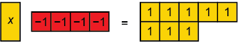 | Solves one-step equations using a model and verifies the solutions  To solve x – 4 = 8, I added 4  one-tiles to each side.  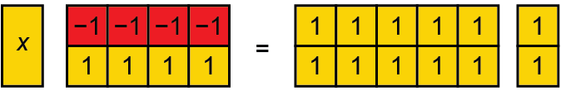  When I removed the zero pairs,  what I had left was x = 12.  To check my answer, I replaced  the x-tile in my original model with 12 one-tiles. When I removed zero pairs, I ended up with 8 one-tiles  on the left side, which matches the right side. | Solves multi-step equations using a model and verifies the solutions  These tiles represent –2x + 8 = 2.  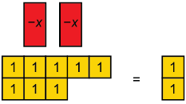  I added 8 negative one-tiles to each side to create zero pairs on the left. When I removed the zero pairs,  I had:  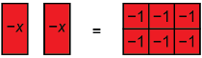  I flipped the tiles on both sides and organized them in 2 equal groups.  It looked like this:  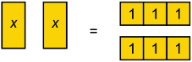  I could see that x = 3. | Creates an equation to represent  a word problem, solves it using  a model, and explains what the solution represents  I used x to represent the cost of each pair of socks. My equation was  4x + 7 = 15.  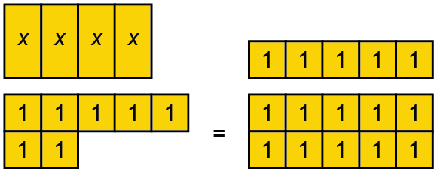  I added 7 negative one-tiles to each side. After removing zero pairs, I got:  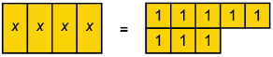  I grouped the tiles on each side in  4 equal groups and saw that x = 2. Each pair of socks cost $2.
Observations/Documentation

