Determining if a Relation is Linear
Determines from a graph whether a relation is linear  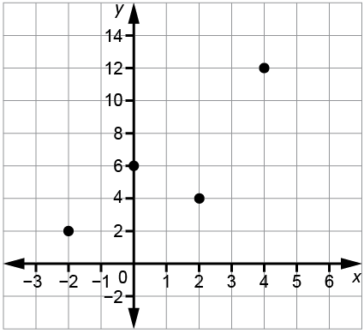  The points on the graph do not lie along a straight line, so the relation is not linear. | Determines whether a relation given as a table of values, set of ordered pairs, or equation is linear by graphing it  I graphed the points (–2, 8), (0, 6), (2, 4), and (4, 2).  They all lie along a line, so the relation is linear.  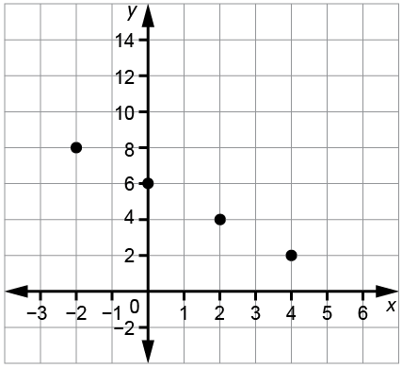 | Determines whether a relation is linear without graphing  The x-values increase by 1 each time. The y-values decrease by 3 most of the time, but not in all cases. So, the relation is not linear.  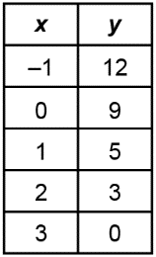 | Adjusts or adds to a graph, table of values, or set of ordered pairs to make it represent a linear relation  I changed the y-value for x = 1 from 5 to 6. Then the y-values decrease by 3 each time so the relation is linear.  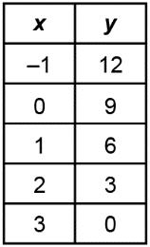
Observations/Documentation

