Representing Linear Relations
Graphs a linear relation as a series of points when given a table of values  I drew a graph to show the data from this table.  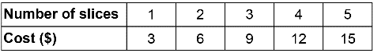  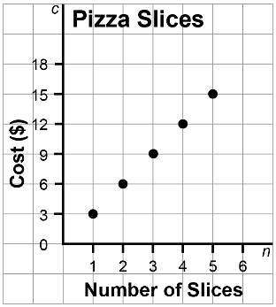 | Distinguishes situations involving discrete and continuous data  I don’t need to join the points on my graph about pizza slices because the store doesn’t sell partial slices. | Represents a linear relation in other forms (graph, table of values, ordered pairs, description, or equation) when given one representation  Every time you buy another slice, the price goes up by $3.  An equation describing the cost of buying n slices is C = 3n. | Analyzes a linear relation and uses it to determine solutions to problems  By extending my table of values,  I can see that it would cost $21 to buy 7 slices of pizza.  By substituting in my equation,  I can see that it would cost $45  to buy 15 slices.
Observations/Documentation

