Choose Your Own Adventure

Patterning and Algebra
Unit 1 Line Master 7

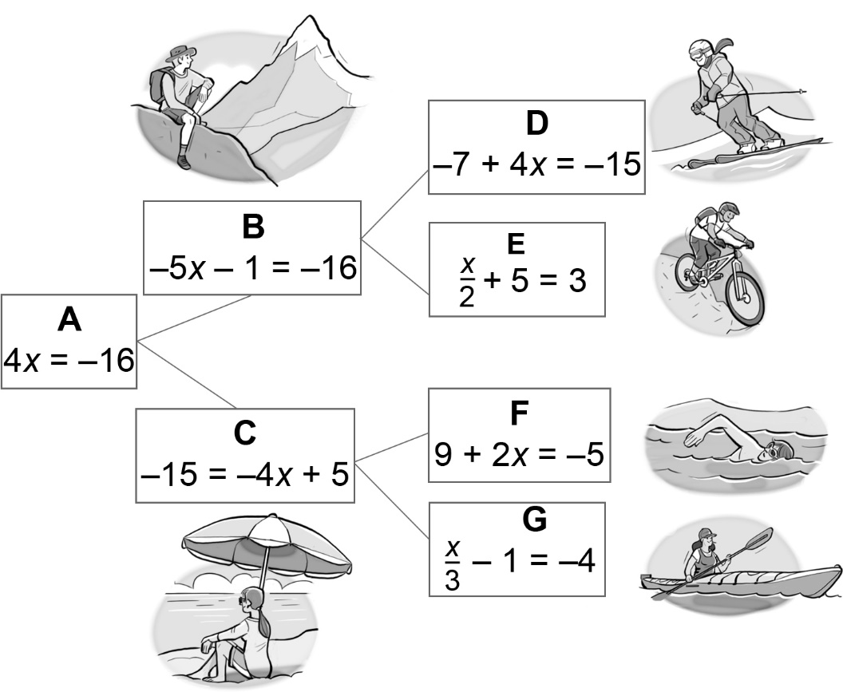

Adventure Totals
Skiing in mountains  A + B + D = −3 | Biking in mountains  A + B + E = −5
Swimming at beach  A + C + F = −6 | Kayaking at beach  A + C + G = −8

