Make it Linear!

Patterning and Algebra
Unit 1 Line Master 6a

Task 1  Is the relation linear?  Explain how you know.  x y  1 2  2 2  3 2  4 2 | Task 2  Is the relation linear?  Explain how you know.  x y  1 6  3 10  4 12  5 14
Task 3  Does this represent a linear relation?  Explain how you know.  You get paid $15 an hour. | Task 4  Explain how you know this relation isn’t linear, then change it so it is.  x y  1 12  3 4  4 2  2 8

Make it Linear! (cont’d)

Patterning and Algebra
Unit 1 Line Master 6b

Task 5  Does this equation represent  a linear relation?  Show how you know.  y = 3x – 1 | Task 6  Two ordered pairs are given.  Write at least 2 more pairs  so that the set represents  a linear relation.  Show your work.  (2, 5) (5, 11)
Task 7  Make a linear relation with the following condition:  Every time the x-value increases by 1, the y-value decreases by 3.  Express the relation as a table of values and an equation. | Task 8  How do you know the relation in this graph is not linear?  Change the graph so it is linear.  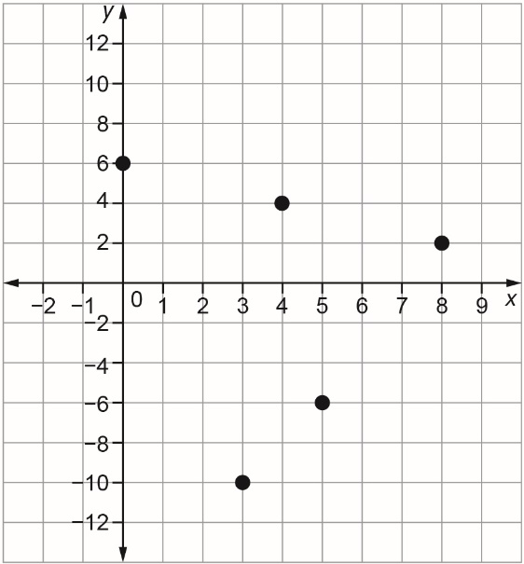

Make it Linear! (cont’d)

Patterning and Algebra
Unit 1 Line Master 6c

Graph to use for  Task 8 solution | Graph to use for  Task 8 solution
Graph to use for  Task 8 solution | Graph to use for  Task 8 solution

