Fencing a Garden

Patterning and Algebra
Unit 1 Line Master 5a

This graph shows the relationship between the side length
of a square garden and the perimeter.
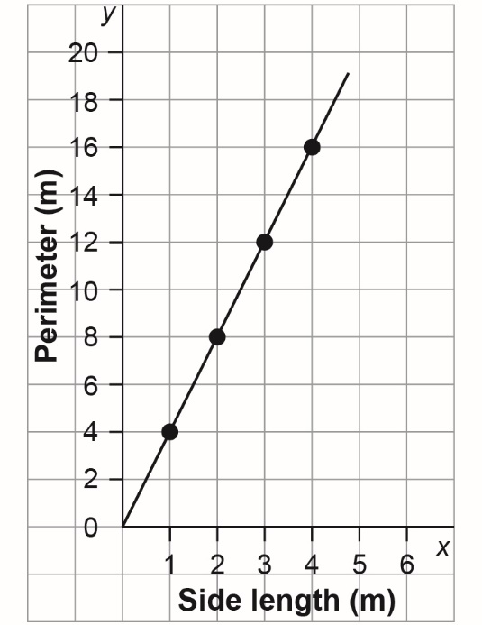
x | y
0
1
2
3
4
1. a) Complete the table of values
for the relationship.

b) What does x represent?

c) What does y represent?

Fencing a Garden (cont’d)

Patterning and Algebra
Unit 1 Line Master 5b

2. Why are the points on the graph joined by a line?

3. Write an equation to describe the relationship in the graph
and table.

4. How much fencing material would a person need to fence
a square garden with sides 6 m long?
How did you determine your answer?

Fencing a Garden (cont’d)

Patterning and Algebra
Unit 1 Line Master 5c

5. Suppose a person has 14 m of fencing.
What is the side length of the largest square garden
they could enclose if the side length does not need
to be a whole number of metres?
How did you determine your answer?

