Graphing and Analyzing
a Linear Relation

Patterning and Algebra
Unit 1 Line Master 4a

Start with the relation y = 3x – 4, where x is an integer.
1. Complete the table of values.
x | −3 | −2 | −1 | 0 | 1 | 2
y

2. Write the information from the table as a series of ordered pairs.

3. Graph the ordered pairs.
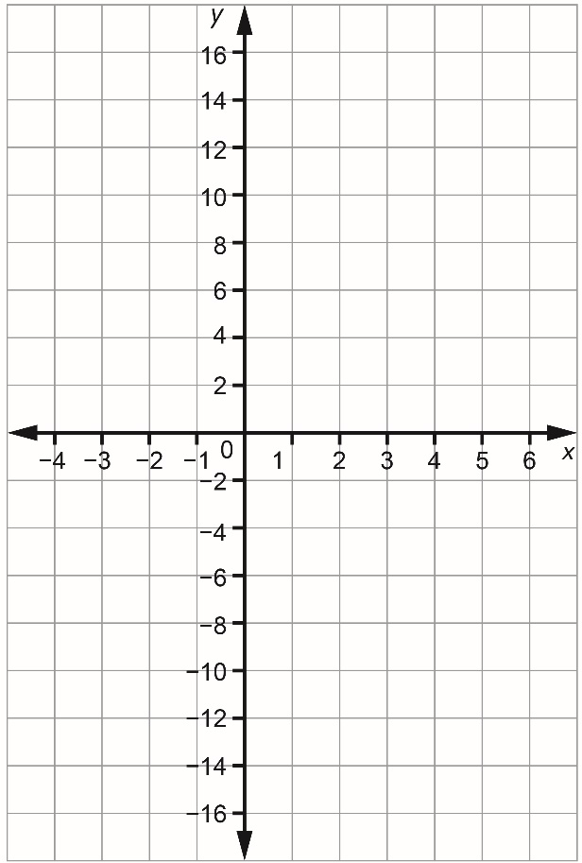
Graphing and Analyzing
a Linear Relation (cont’d)

Patterning and Algebra
Unit 1 Line Master 4b

4. Is this an increasing or decreasing graph?
Explain how you know.

5. What is the value of y when x is 6?
How did you determine your answer?

6. Does the point (4, 9) lie on the graph?
How do you know?

