Patterning and Algebra
Unit 1 Line Master 1
Writing and Interpreting Expressions

Description or Pattern | Expression
The number of squares in
term n
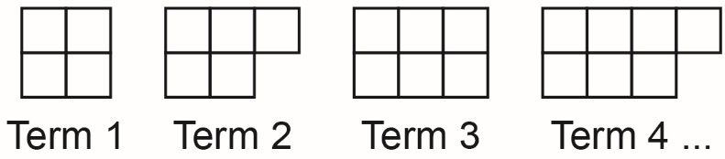
5 more than the product of a
number and 4.5
The sum of 3 times a number and 1.5 times the same number
Triple the sum of 7.5 and
a number
A number divided by 2, then increased by 20
 | 2.5n + 32
 | 16 – 12x
A gardener plants n rows of beans and n rows of carrots.
Each row of beans has 8 plants.
Each row of carrots has 12 plants. How many plants are there in all?

