Dividing Fractions and Mixed Numbers
Models division of a fraction by  a whole number  $\frac{1}{2}$÷ 3  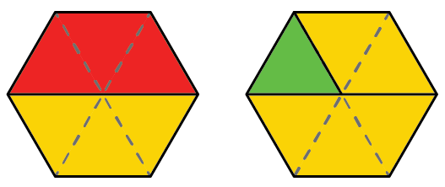  I used pattern blocks. A trapezoid is  $\frac{1}{2}$. A trapezoid is made up of  3 triangles. So, $\frac{1}{2}$÷ 3 is $\frac{1}{6}$. | Models division of fractions and mixed numbers  $\frac{5}{6}$÷ $\frac{1}{2}$  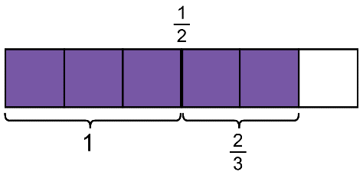  I divided a rectangle in sixths and shaded 5 parts.  Then, I drew a line to cut the same rectangle in half. $\frac{1}{2}$ goes into $\frac{5}{6}$ once and then $\frac{2}{3}$ more.  So, $\frac{5}{6}$÷ $\frac{1}{2}$= 1$\frac{2}{3}$. | Applies a rule for dividing fractions, including mixed numbers  2$\frac{3}{4}$÷ 1$\frac{1}{2}$  I wrote the mixed numbers as improper fractions. Then, I wrote  the fractions with a common denominator and divided the numerators.  2$\frac{3}{4}$÷ 1$\frac{1}{2}$= $\frac{11}{4}$÷ $\frac{3}{2}$  = $\frac{11}{4}$÷ $\frac{6}{4}$  = $\frac{11}{6}$  = 1$\frac{5}{6}$ | Solves a problem involving the division of fractions and mixed numbers  A painter used 2$\frac{3}{4}$ cans of paint for the first room and 1$\frac{1}{2}$ cans for the second room. How many more times as much paint did the first room use than the second?  2$\frac{3}{4}$÷ 1$\frac{1}{2}$= $\frac{11}{4}$÷ $\frac{3}{2}$  = $\frac{11}{4}$× $\frac{2}{3}$  = $\frac{22}{12}$  = 1$\frac{10}{12}$  = 1$\frac{5}{6}$  The first room used 1$\frac{5}{6}$ times as much paint as the second room.
Observations/Documentation

