Multiplying Fractions and Mixed Numbers
Models multiplication of a fraction  by a whole number  5 × $\frac{1}{3}$  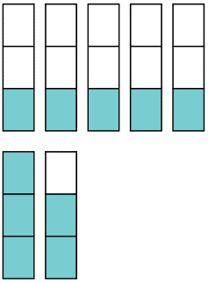  I divided one rectangle into 3 equal pieces and shaded 1 part of the rectangle. I repeated the process  for a total of 5 of these rectangles. Altogether, these combined to  $\frac{5}{3}$or 1$\frac{2}{3}$. | Models multiplication of fractions  or mixed numbers  $\frac{1}{2}$× $\frac{3}{4}$  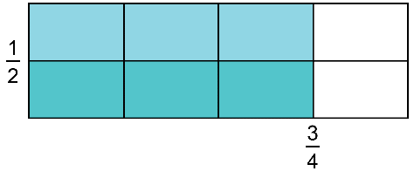  I drew a rectangle. Next, I drew a line to cut the width of the rectangle in half. Then I drew lines to cut the length into fourths. I shaded three-fourths of the rectangle light blue. Then I shaded one-half of the  three-fourths a darker blue.  This showed 3 of 8 parts as shaded  dark blue. So, $\frac{1}{2}$× $\frac{3}{4}$= $\frac{3}{8}$. | Applies a rule for multiplying fractions, including mixed numbers  1$\frac{1}{2}$× 2$\frac{5}{6}$  I can write the mixed numbers as improper fractions, then multiply the numerators and denominators.  1$\frac{1}{2}$× 2$\frac{5}{6}$= $\frac{3}{2}$× $\frac{17}{6}$  = $\frac{3 × 17}{2 × 6}$  = $\frac{51}{12}$  = 4$\frac{3}{12}$  = 4$\frac{1}{4}$ | Solves a problem involving the multiplication of fractions or mixed numbers  A musician spends 3$\frac{3}{8}$h practicing scales each week. How many hours does the musician spend practising scales in 2$\frac{1}{2}$weeks?  3$\frac{3}{8}$× 2$\frac{1}{2}$  = (3 + $\frac{3}{8}$) × (2 + $\frac{1}{2}$)  = (3 × 2) + (3 × $\frac{1}{2}$) + ($\frac{3}{8}$× 2) + ($\frac{3}{8}$× $\frac{1}{2}$)  = 6 + $\frac{3}{2}$+ $\frac{6}{8}$+ $\frac{3}{16}$  = 6 + $\frac{24}{16}$+ $\frac{12}{16}$+ $\frac{3}{16}$  = 6 + $\frac{39}{16}$  = 6 + 2 $\frac{7}{16}$  = 8$\frac{7}{16}$  The musician spends 8$\frac{7}{16}$h  practising scales.
Observations/Documentation

