Subtracting Fractions and Mixed Numbers
Models subtraction of fractions or mixed numbers with like denominators  $\frac{7}{8}$− $\frac{5}{8}$  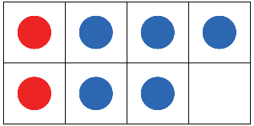  I used a frame with 8 parts. I drew  7 circles for $\frac{7}{8}$. I shaded 5 circles blue  for $\frac{5}{8}$, then shaded the remaining circled red. The difference is 2.  So, $\frac{7}{8}$− $\frac{5}{8}$= $\frac{2}{8}$. | Models subtraction of fractions or mixed numbers with unlike denominators  $\frac{7}{12}$−$\frac{1}{4}$  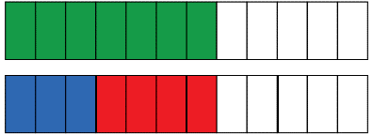  I divided one fraction strip (rectangle) into 12 equal pieces and another fraction strip (rectangle)into 4 equal pieces. I shaded 7 parts of the first fraction strip (rectangle)and 1 part of the second fraction strip (rectangle). I needed the sizes of the pieces to be the same, so I divided the 4 parts of the second fraction strip (rectangle) into 3 parts each; altogether this made 12 parts. This showed 7 of 12 parts and 3 of 12 parts being shaded. The difference  is 4 parts. So, the answer is $\frac{4}{12}$, which is $\frac{1}{3}$ . | Uses equivalent fractions to subtract fractions or mixed numbers  1$\frac{1}{2}$− $\frac{7}{6}$= $\frac{3}{2}$− $\frac{7}{6}$  = $\frac{9}{6}$− $\frac{7}{6}$  = $\frac{2}{6}$  = $\frac{1}{3}$ | Solves a problem involving the subtraction of fractions or mixed numbers  A student studied 1$\frac{1}{3}$ h for a math  test and 2$\frac{3}{4}$h for a science test.  How much longer did the student study for the science test?  2$\frac{3}{4}$− 1$\frac{1}{3}$= (2 − 1) + ($\frac{3}{4}$− $\frac{1}{3}$)  = (2 − 1) + ($\frac{9}{12}$− $\frac{4}{12}$)  = 1 + $\frac{5}{12}$  = 1$\frac{5}{12}$  The student studied 1$\frac{5}{12}$h longer  for the science test.
Observations/Documentation

