Adding Fractions and Mixed Numbers
Models addition of fractions or mixed numbers with like denominators  $\frac{3}{6}$+ $\frac{2}{6}$  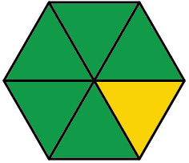  I used pattern blocks. A triangle is $\frac{1}{6}$.  So, 3 + 2 = 5 triangles make $\frac{5}{6}$.  So, $\frac{3}{6}$+ $\frac{2}{6}$= $\frac{5}{6}$. | Models addition of fractions or mixed numbers with unlike denominators  $\frac{1}{2}$+ $\frac{7}{12}$  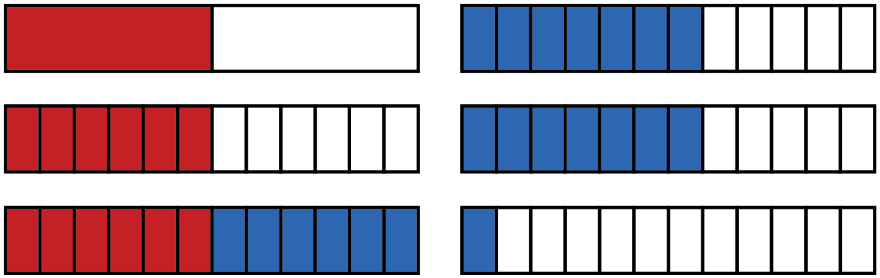  I divided one fraction strip (rectangle) into 2 equal pieces and another fraction strip (rectangle) into  12 equal pieces. I shaded 1 part of the first fraction strip (rectangle) and 7 parts of the second fraction strip (rectangle). I needed the sizes of the pieces to be the same,  so I divided the 2 parts of the first fraction strip (rectangle) into 6 parts each; altogether this made 12 parts.  This showed 6 of 12 parts and 7 of 12 parts being shaded. Altogether, this combined to 13 parts. There are 12 parts in one whole, so the answer  is 1$\frac{1}{12}$. | Uses equivalent fractions to add fractions or mixed numbers  1$\frac{1}{2}$+ $\frac{7}{6}$  1$\frac{1}{2}$+ $\frac{7}{6}$= $\frac{3}{2}$+ $\frac{7}{6}$  = $\frac{9}{6}$+ $\frac{7}{6}$  = $\frac{16}{6}$  = 2$\frac{4}{6}$  = 2$\frac{2}{3}$ | Solves a problem involving the addition of fractions or mixed numbers  A student studied 1$\frac{3}{4}$h for a math  test and 1$\frac{2}{3}$ h for a science test.  How long did the student study  in total?  1$\frac{3}{4}$+ 2$\frac{1}{3}$  = (1 + 2) + ($\frac{3}{4}$+ $\frac{1}{3}$)  = (1 + 2) + ($\frac{9}{12}$+ $\frac{4}{12}$)  = 3 + $\frac{13}{12}$  = 3 + 1 +$\frac{1}{12}$  = 4$\frac{1}{12}$  The student studied for 4$\frac{1}{12}$h.
Observations/Documentation

