Working with Fractional Percents
Represents a fractional percent between 0% and 1% on a grid  How could you represent $\frac{1}{4}$% on a hundredths grid?  $\frac{1}{4}$% is one-fourth of 1%, so $\frac{1}{4}$% is  one-fourth of a square on a hundredths grid.  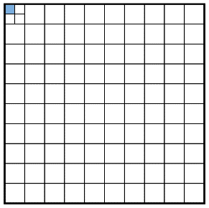 | Determines a fractional percent between 0% and 1%  What is $\frac{2}{5}$% of 250?  1% of 250 = 250 ÷ 100  = 2.5  $\frac{1}{5}$% of 250 = 2.5 ÷ 5  = 0.5  So, $\frac{2}{5}$% of 250 = 2 × 0.5  = 1 | Determines a decimal percent of a number  What is 36.5% of 470?  36.5%  = (3 × 10%) + (6 × 1%) + (5 × 0.1%)  10% of 470 = 47  1% of 470 = 4.7  0.1% of 470 = 0.47  So, 36.5% of 470  = (3 × 47) + (6 × 4.7) + (5 × 0.47)  = 171.55  Or  36.5% of 470  = 0.365 × 470  = 171.55 | Solves a problem involving a fractional percent  As an incentive to get new customers, a bank offers an interest rate of 3.5% for a set time period.  How much would a person earn if they invested $255 for that time?  3.5% of $255  = 0.035 × $255  ≈ $8.93
Observations/Documentation

