Solving Problems Involving Ratios, Rates, and Proportions
Understands the difference between a ratio and a rate  A ratio is a comparison of two quantities with the same units (e.g., 3 blue crayons to 5 green crayons).  A rate is a comparison of two quantities with different units  (e.g., 3 kg for $6, 100 km in 2 h). | Understands that ratios and rates are related by multiplication  How can you determine a ratio equivalent to 3:7?  Multiply each term by the same number, e.g., 3:7 = 6:14  How can you determine a rate equivalent to 70 heartbeats in  1 min? Multiply each quantity by the same number ,e.g., 140 heartbeats in 2 min. | Distinguishes between a ratio and  a rate  A recipe uses 30 g of sugar for every 2 cups dry ingredients. How many grams of sugar are in 1 cup?  Does this problem involve a ratio  or a rate?  The problem involve a rate because the units are different. | Uses a variety of strategies to solve problems involving ratios, rates, and proportions.  On a class trip, for every 3 students who skied, 2 snow-boarded.  64 students snow-boarded.  How many students skied?  Let s represent the number of students who skied.  Use equivalent ratios.  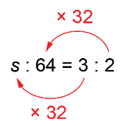  s = 3 × 32  s = 96  Use a proportion.  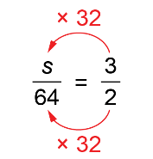  s = 3 × 32  s = 96  96 students skied.
Observations/Documentation

