Exploring Rates
Understands what a rate is  A rate is a comparison of two quantities with different units,  e.g., 3 kg for $6, 100 km in 2 h | Writes a rate as a unit rate  Divide to write a rate as a unit rate, e.g., 3 kg for $6 is $2/kg, 100 km in 2 h is 50 km/h | Uses a graph to represent a rate, and solve a related problem  For a typing speed of 40 words/min, how long would it take to type  100 words?  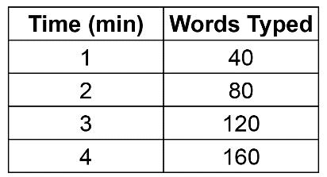  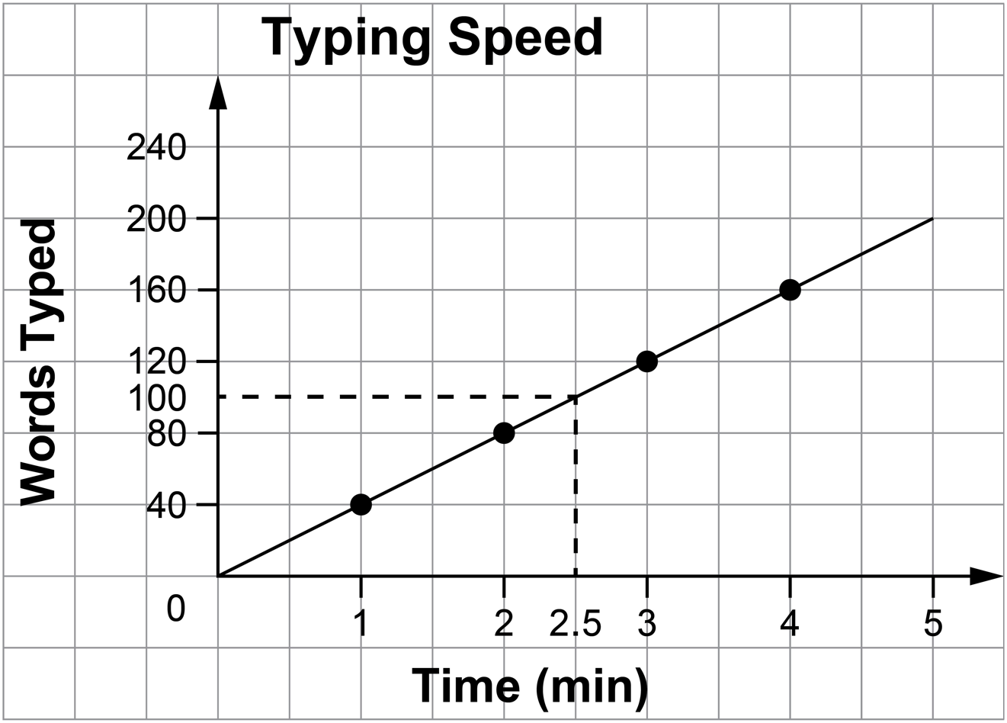  From the graph, 100 words would be typed in 2.5 min. | Uses a proportion to solve a rate problem  For a typing speed of 40 words/min, how long would it take to type  240 words?  Let t minutes represent the time.  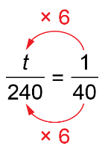  t = 6  It would take 6 min.
Observations/Documentation

