Relating Ratio and Proportion
Writes a ratio in simplest form  The terms in the ratio 28:12 have  4 as their greatest common factor.  In simplest form, 28:12 = 7:3 | Writes equivalent ratios for  a two-term ratio  Equivalent ratios for 24:16 are  12:8, 6:4, 3:2, and 48:32 | Uses equivalent ratios to identify an unknown number in a ratio table  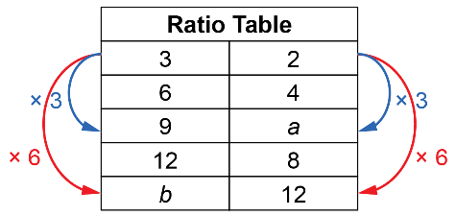  For a:  1st column: 3 × 3 = 9  2nd column: 2 × 3 = a  So, a = 6  For b:  2nd column: 2 × 6 = 12  1st column: 3 × 6 = b  So, b = 18 | Uses a proportion to solve  a ratio problem  For a:  3:2 = 9:a  Write each ratio as a fraction.  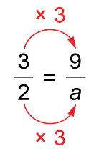  a = 2 × 3  a = 6
Observations/Documentation

