Dividing Integers
Uses a model to divide two positive integers  (+6) ÷ (+3) = +2  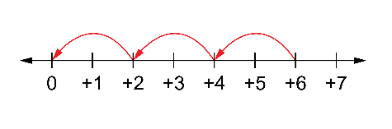  When the dividend and divisor have the same sign, the quotient is positive. | Uses a model to divide a negative integer by a positive integer  (–6) ÷ (+3) = –2  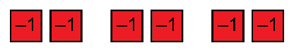  When the dividend and divisor have opposite signs, the quotient is negative. | Uses the inverse relationship between multiplication and division to divide integers with opposite signs  (+2) × (–3) = –6, so (–6) ÷ (+2) = –3  When the dividend and divisor have opposite signs, the quotient is negative. | Uses the relationship between multiplication and division to divides two negative integers  (+8) × (–2) = –16,  so (–16) ÷ (–2) = (+8)  (+3) × (–4) = –12,  so (–12) ÷ (–4) = +3  When the dividend and divisor have the same sign, the quotient is positive.
Observations/Documentation

