Multiplying Integers
Uses a model to multiply two positive integers  (+2) × (+5) = +10  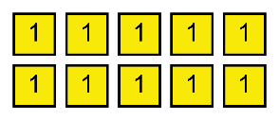  The product of two positive integers is positive. | Uses a model to multiply a positive integer by a negative integer  (+2) × (–5) = –10  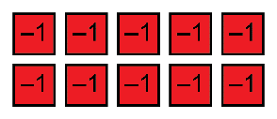  The product of positive integer and a negative integer is negative. | Uses the commutative property to multiply a negative integer by a positive integer  (–5) × (+2) is equivalent to  (+2) × (–5), so (–5) × (+2) = –10.  The product of negative integer and a positive integer is negative. | Extends a pattern to multiply two negative integers  (+3) × (–4) = –12  (+2) × (–4) = –8  (+1) × (–4) = –4  (0) × (–4) = 0  (–1) × (–4) = 4  (–2) × (–4) = 8  The product of two negative integers is positive.
Observations/Documentation

