Adding and Subtracting Integers
Uses integer tiles and a number line to add integers with the same sign  (+2) + (+5) = +7  (–1) + (–3) = –4  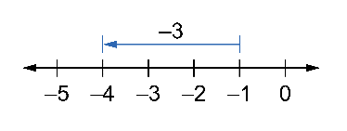 | Uses a number line and integer tiles to add integers with opposite signs  (–2) + (+5) = +3  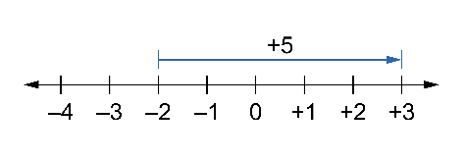  (+1) + (–3) = –2  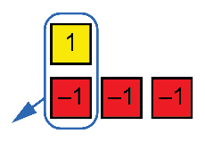 | Uses integer tiles and a number line to subtract integers with the  same sign  (+2) – (+5) = –3  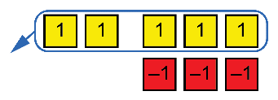  (–1) – (–3)  Add the opposite.  (–1) + (+3) = +2  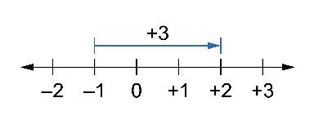 | Subtracts integers with opposite signs  (+2) – (–5) = (+2) + (+5)  = +7  (–1) – (+3)  Add the opposite.  (–1) + (–3) = –4
Observations/Documentation

