Exploring Rotations of 3-D Objects
Identifies different views of  3-D objects  Match the views to the object.  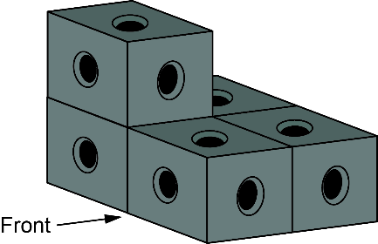  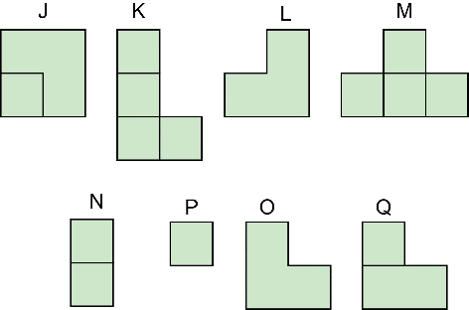  Front view: O, right side: Q,  left side: L, top view: J | Predicts top, front, and side views of a rotated 3-D object  Predict the views after a horizontal  rotation of 270° clockwise.  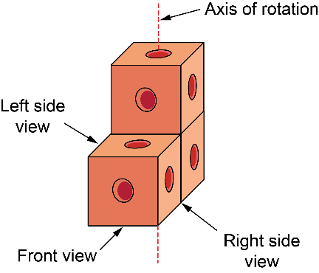  A rotation of 270° clockwise is three 90° turns clockwise. So, the front becomes the right side, the left side becomes the front, the back becomes the left side, and the top rotates by 270° clockwise. | Draws top, front, and side views of  a rotated 3-D object  Draw the views after a horizontal  rotation of 270° clockwise.  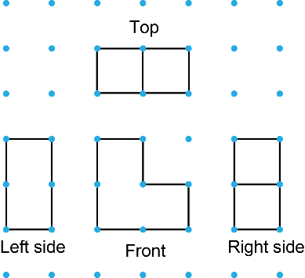 | Applies knowledge of different views  Describe a different rotation that will have the same views as a horizontal rotation of 270° clockwise.  A rotation of 270° clockwise is the same as a rotation of 90° counterclockwise.
Observations/Documentation

