Building 3-D Objects from their Views
Identifies 3-D objects from their top, front, and side views  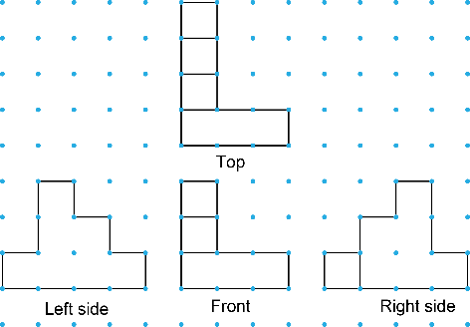  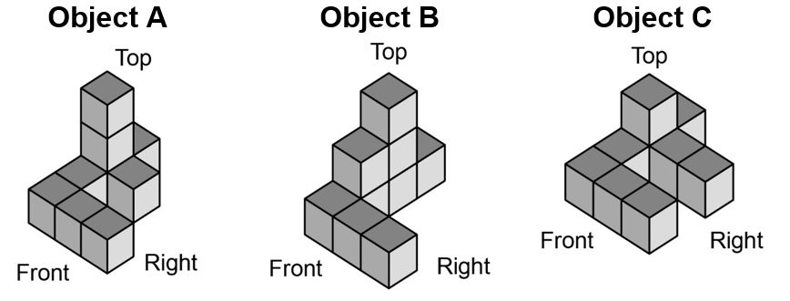  The views match Object B. | Understands that each view provides information about the shape of the object  Starting with one view, fewer objects can be built as another view is added. I altered the object by adding or moving cubes so the object matched all the given views. | Builds 3-D objects from their top, front, and side views  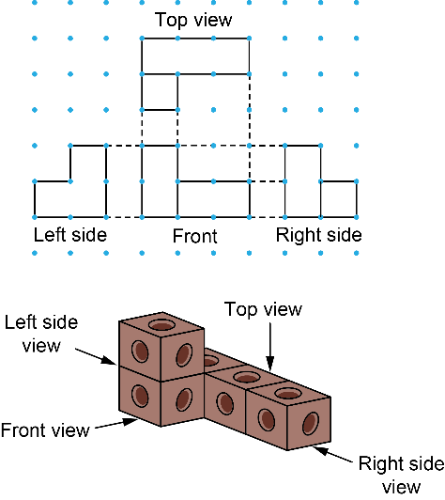 | Applies knowledge of views to build multiple 3-D objects  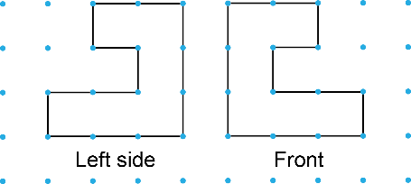  I used 6 cubes to build the left side view. Then added 2 cubes match the front view. So, the minimum number of cubes needed is 8.  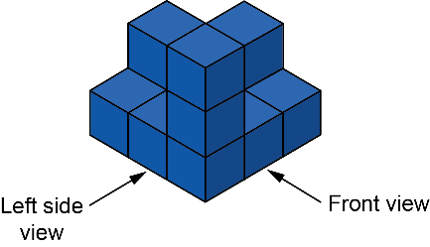  I can complete the bottom level and the object still matches the views. So, the maximum number of cubes needed is 12.  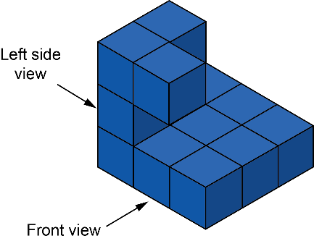

Observations/Documentation

