Sketching Views of 3-D Objects
Recognizes and sketches different views of objects made from rectangular prisms  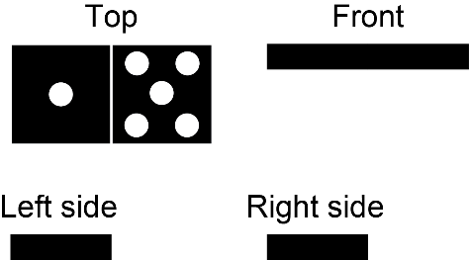 | Draws top, front, and side views of a 3-D object composed of right rectangular prisms  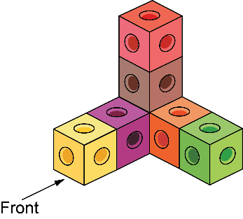  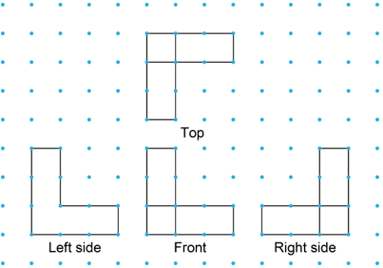 | Makes an isometric drawing of a 3-D object composed of right rectangular prisms  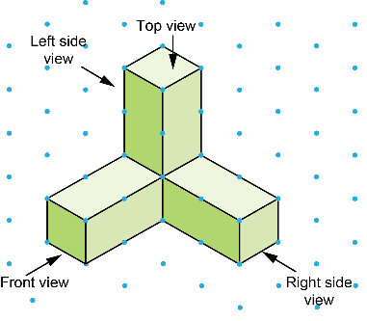 | Applies knowledge of different views  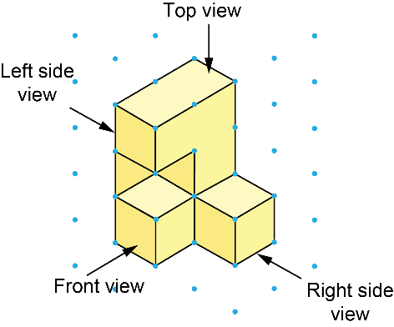  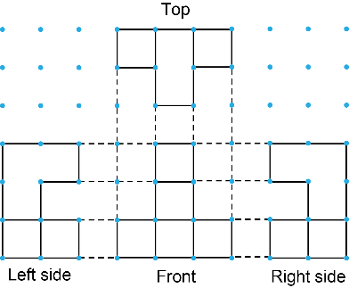
Observations/Documentation

