Determining the Volume of Prisms and Cylinders
Understands that the volume of a right prism is the area of its base times height  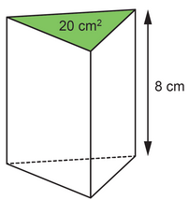  The volume of the right triangular prism is  20 × 8 = 160 cm³. | Determines the volume of a right cylinder  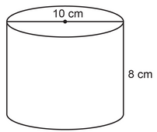  area of base:  $π$ × r² ≈ 3.14 × 5²  = 78.5  The area of the base is  about 78.5 cm².  Volume:  A × h ≈ 78.5 × 8  = 628  The volume is about 628 cm³. | Understands that orientation of a right prism or right cylinder does not affect its volume  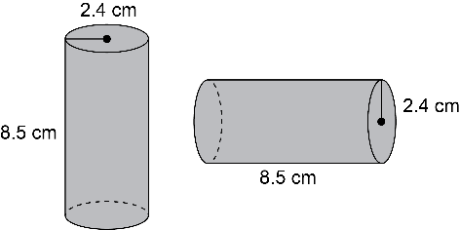  The cylinders have the same volume because they have the same radius and height. | Determines a missing dimension of a right prism or right cylinder  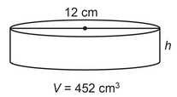  What is the approximate height of the cylinder?  Volume:  V = $π$r²h  452 ≈ 3.14 × 6² × h  452 = 113.04 × h  h = 452 ÷ 113.04  h ≈ 4  The height is about 4 cm.
Observations/Documentation

