Determining the Surface Area of Prisms and Cylinders
Uses nets to calculate surface area by adding the partial areas  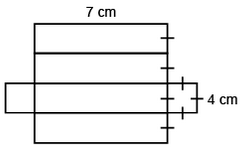  I added the partial areas.  Area of rectangle:  7 cm × 4 cm = 28 cm²  Area of 4 rectangles:  4 × 28 cm² = 112 cm²  Area of square:  4 cm × 4 cm = 16 cm²  Area of 2 squares:  2 × 16 cm² = 32 cm²  Surface area of right prism:  112 cm² + 32 cm² = 144 cm² | Uses nets to show relationship between areas of faces and surface area of right prisms and cylinders  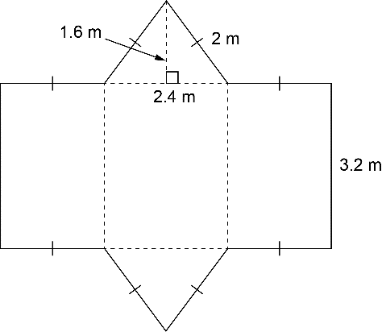  Surface area of right triangular prism  = area of 2 congruent triangles +  area of 2 congruent rectangles +  area of third rectangle  = 2(2.4 × 1.6 ÷ 2) + 2(3.2 × 2)  + 3.2 × 2.4  = 3.84 + 12.8 + 7.68  = 24.32  The surface area is 24.32 m². | Determines surface area by visualizing net and adding the areas of its faces  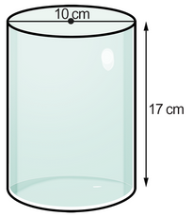  Surface area of right cylinder  = area of curved surface + area of  2 congruent circles  = $π$dh + 2$π$r²  ≈ 3.14 × 10 × 17 + 2 × 3.14 × 5²  = 533.8 + 78.5  = 612.3  The surface area is about 612.3 cm². | Solves problems involving surface area of right prisms or cylinders  The dimensions of a rectangular gift box are 8 cm by 7 cm by 9 cm.  How much wrapping paper is needed for this gift?  Surface area of right rectangular prism  = 2(8 × 7) + 2(8 × 9) + 2(7 × 9)  = 112 + 144 + 126  = 382  The surface area is 382 cm². You would need 382 cm² of wrapping paper without overlap.
Observations/Documentation

