Applying the Pythagorean Theorem to Solve Problems
Describes how to use the Pythagorean theorem  I can substitute the known side lengths into a² + b² = c², where a and b are the lengths of the shorter sides and c is the length of hypotenuse, to find the unknown length in a right triangle. | Uses Pythagorean triples to solve a problem  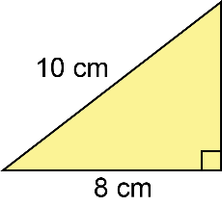  Since 10² – 8² = 36 is a perfect square, the side lengths are a Pythagorean triple.  The missing side length is 6 cm. | Uses the Pythagorean theorem to determine an unknown side length  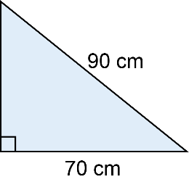  a² + b² = c²  a ² + 70² = 90²  a ² + 4900 = 8100  a² = 8100 – 4900  a² = 3200  a = $\sqrt{3200}$  a ≈ 56.6  The length of the missing side is about 56.6 cm. | Uses the Pythagorean theorem to solve problems involving an unknown side length in a right triangle  A surveyor measures the base of a vertical cliff to be 150 m away and the top of the cliff to be 188 m away. How high is the cliff?  Draw a diagram.  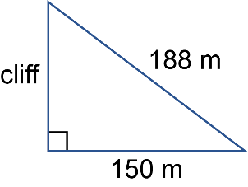  a² + b² = c²  a ² + 150² = 188²  a ² + 22 500 = 35 344  a² = 35 344 – 22 500  a² = 12 844  a = $\sqrt{12 844}$  a ≈ 113.33  The height of the cliff is about 113.33 m.
Observations/Documentation

