Surface Area of a Triangular Prism
Measurement
Unit 1 Line Master 9a

Note: Each prism is drawn to scale.
Prism 1: Sketch and label the net of the right triangular prism.
Determine the surface area.
Develop a formula to determine the surface area
of the prism.

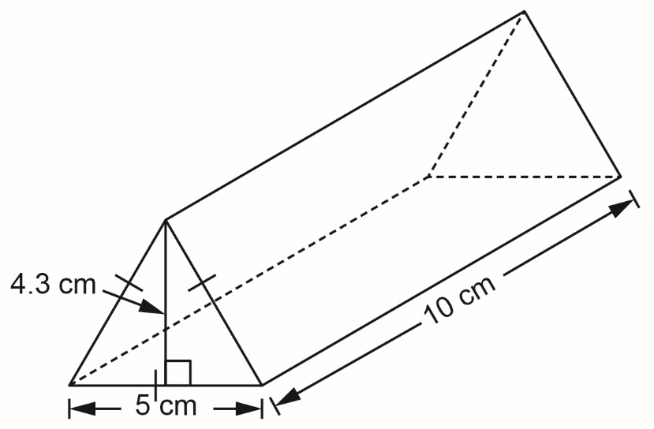

Surface Area of a Triangular Prism
(cont’d)
Measurement
Unit 1 Line Master 9b

Prism 2: Sketch and label the net of the triangular prism.
Determine the surface area.
Develop a formula to determine the surface area
of the prism.

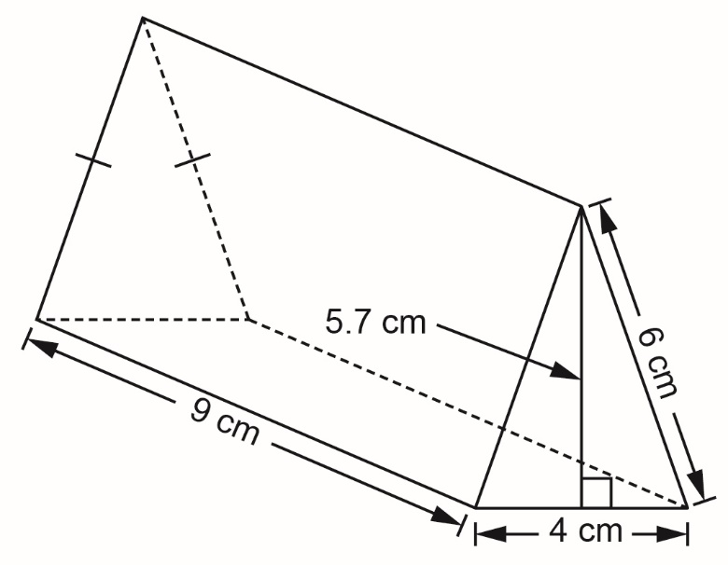

Surface Area of a Triangular Prism
(cont’d)
Measurement
Unit 1 Line Master 9c

Prism 3: Sketch and label the net of the triangular prism.
Determine the surface area.
Develop a formula to determine the surface area
of the prism.

