Nets of Prisms and Cylinders

**Measurement**

**Unit 1 Line Master 7a**

Nets of Prisms and Cylinders (cont’d)

**Measurement**

**Unit 1 Line Master 7b**

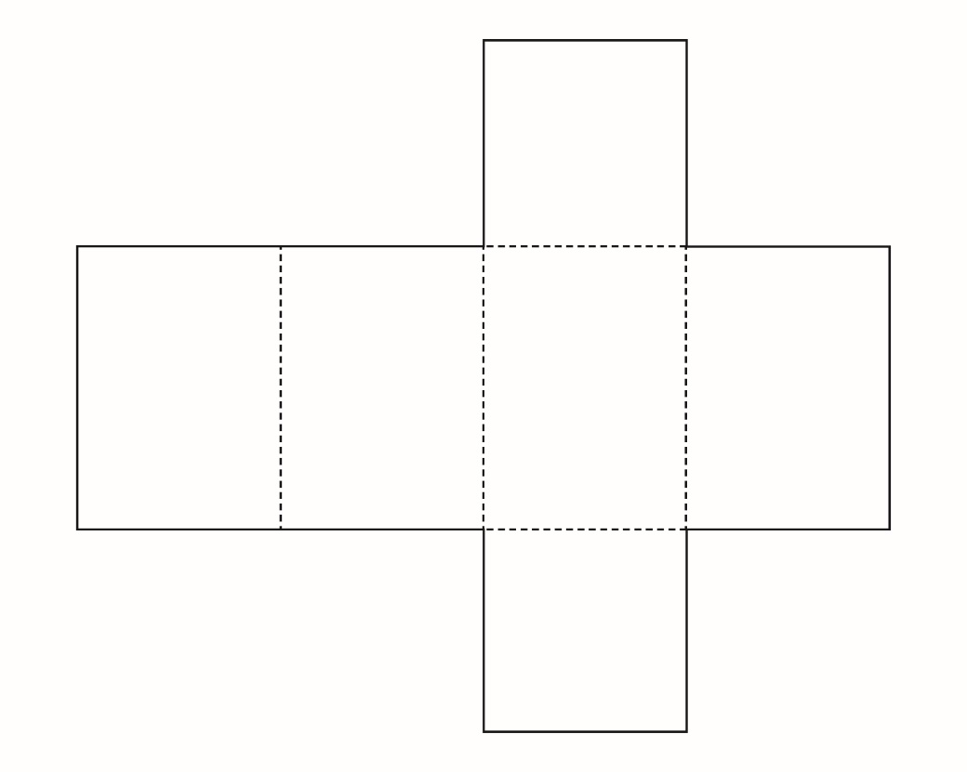

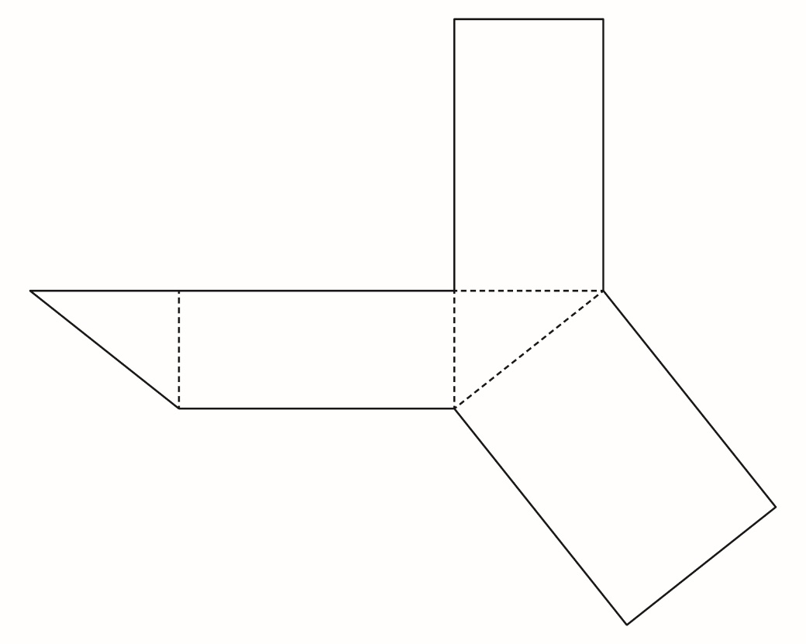

Nets of Prisms and Cylinders (cont’d)

**Measurement**

**Unit 1 Line Master 7c**

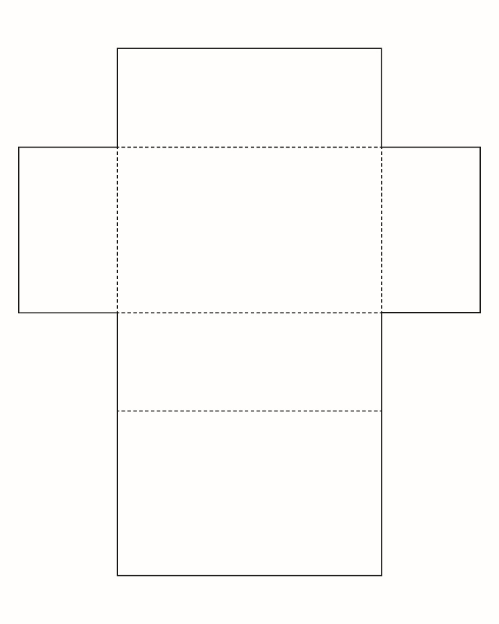

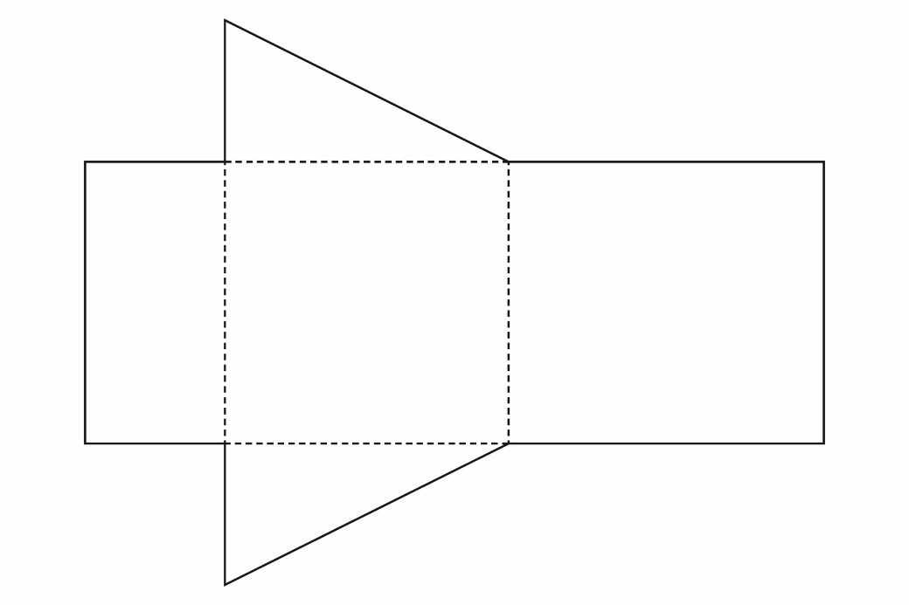

Nets of Prisms and Cylinders (cont’d)

**Measurement**

**Unit 1 Line Master 7d**

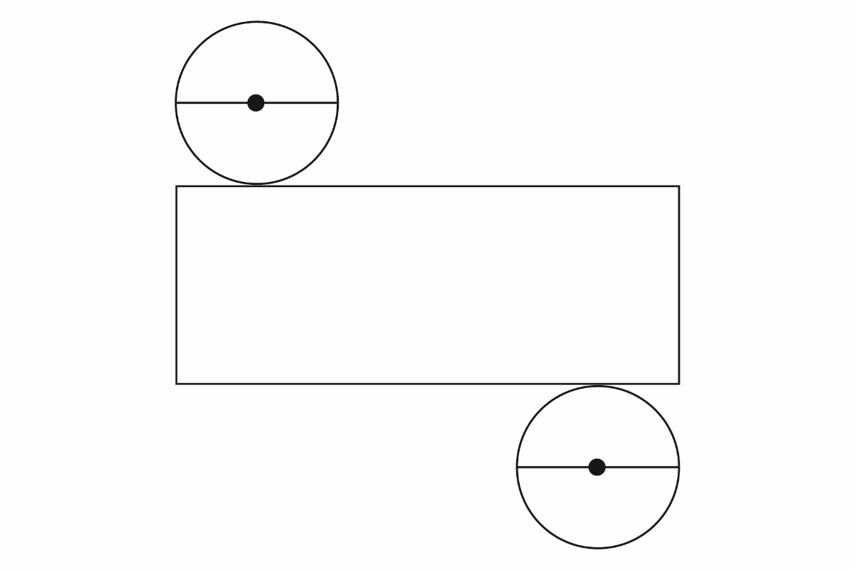

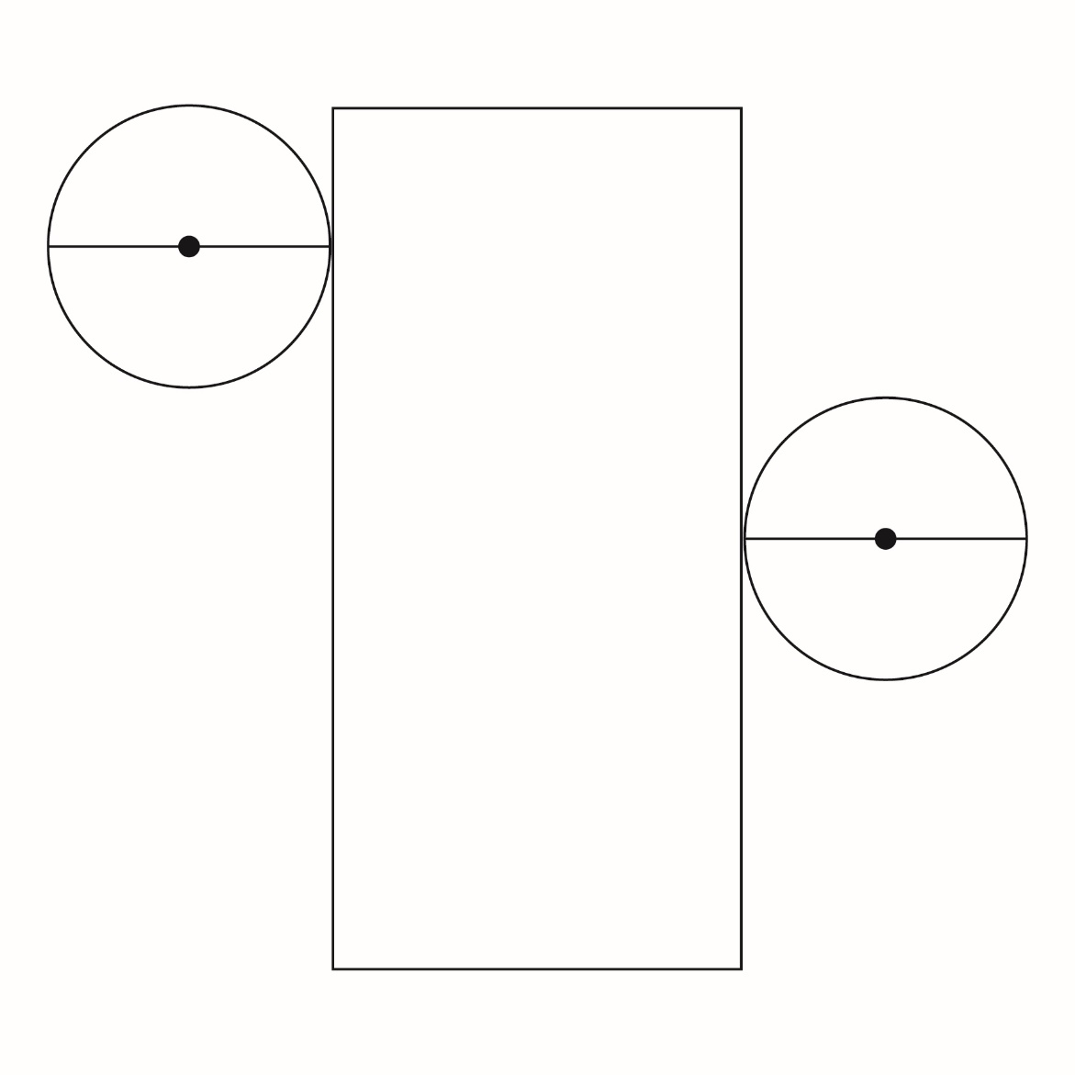

Nets of Prisms and Cylinders (cont’d)

**Measurement**

**Unit 1 Line Master 7e**

