Applying the Pythagorean Theorem
Measurement
Unit 1 Line Master 5

Suppose the length of each side of the square created by using tangrams is 32 cm. Using the Pythagorean theorem and mental math strategies, determine the lengths of all sides of each of the seven tangram pieces. Round answers to two decimal places. Label the lengths on the diagram.
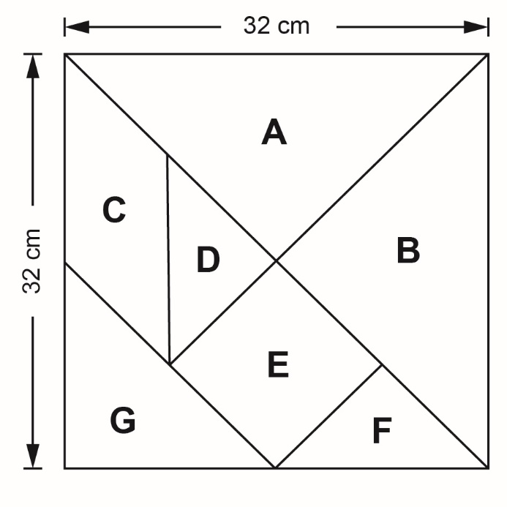

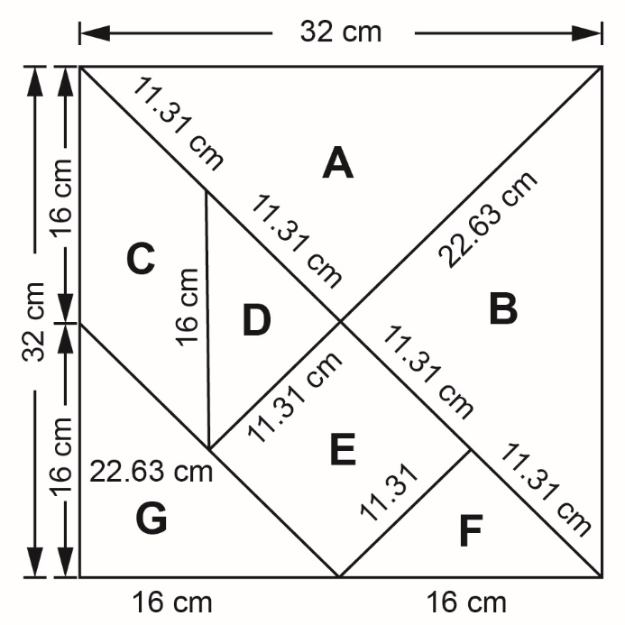
Answer:

