Building Objects from Views
Measurement
Unit 1 Line Master 18a

Part A: Given one view
Build an object that has this left side view.
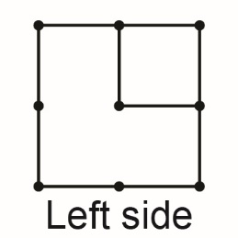

How many different objects can you build?

Building Objects from Views
Measurement
Unit 1 Line Master 18b

Part B: Given two views
Build an object that has these left side and front views.
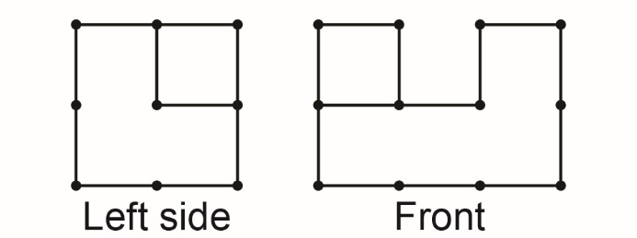

How many different objects can you build?

Building Objects from Views (cont’d)
Measurement
Unit 1 Line Master 18c

Part C: Given three views
Build an object that has these left side, front, and top views.
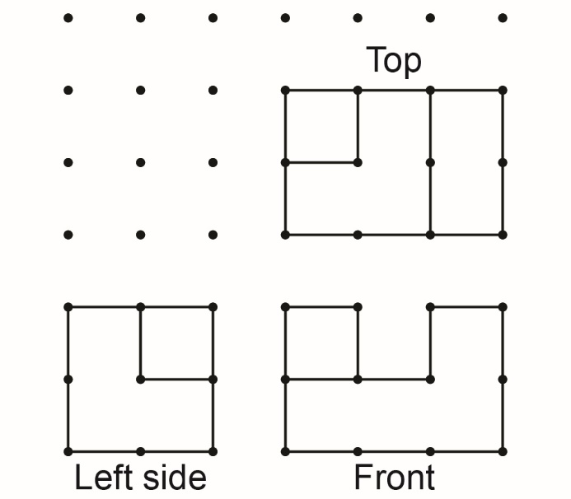

How many different objects can you build now?

Building Objects from Views (cont’d)
Measurement
Unit 1 Line Master 18d

Part D: Given four views
Here is the right side view. Is your object correct?
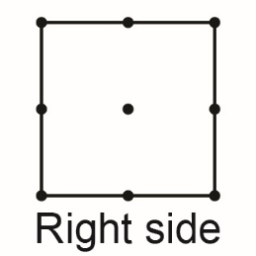

If not, add or move cubes until it is.

What did you notice as more views were given?

