Surface Area of a Right Cylinder
Measurement
Unit 1 Line Master 10

You will need 3 sheets of letter paper (21.6 cm by 27.9 cm),
scissors, and tape.

1. Construct two cylinders.
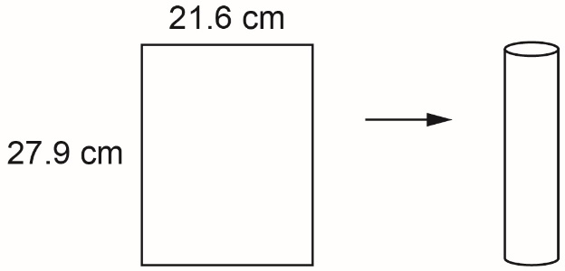
- Use one sheet of paper. Roll it
lengthwise and tape it to make the curved surface of a cylinder.
Trace the ends of the cylinder to
make circles and tape them to
close your cylinder.
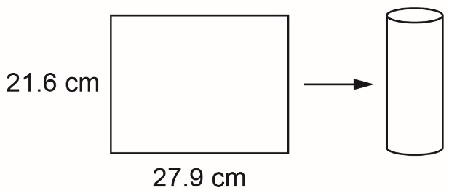
- Use one sheet of paper. Roll it
widthwise and tape it to make the curved surface of a cylinder.
Trace the ends of the cylinder to
make circles and tape them to
close your second cylinder.

2. Predict which cylinder will have the greater surface area.

3. Determine the surface area of each of your cylinders.
Use 3.14 as an approximation for $π$.
Which one has the greater surface area? Why?

