Using Transformations to Describe Tessellations
Identifies and describes transformations of a polygon  in a tessellation  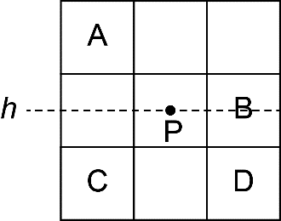  Square A is translated 2 units right, 1 unit down to its Image B.  Square A is reflected in a horizontal line h to its Image C.  Square A is rotated 180⁰ about point P to its Image D. | Identifies a combination of transformations in a tessellation  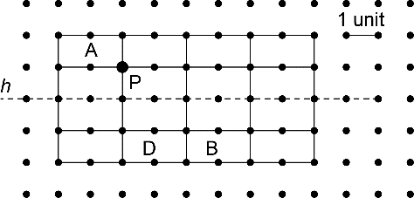  Shape A is translated 4 units right, then reflected in line h to its Image B.  Shape A is rotated 180⁰ about point P, then translated 2 units down to its Image D. | Creates a tessellation and describes the transformation(s)  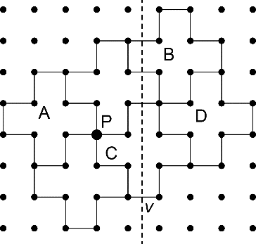  Shape A is translated 4 units right and 2 units up to its Image B.  Shape A is rotated 180⁰ about point P to its Image C.  Shape A is reflected in line v to its Image D. | Creates a new shape, then tessellates it  I started with Shape A. I cut off 1 square and taped it to the opposite side. Then, I used the revised shape to create a tessellation.  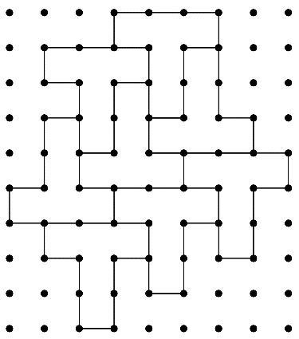
Observations/Documentation

