Exploring Tessellations
Identifies and explains a tessellation  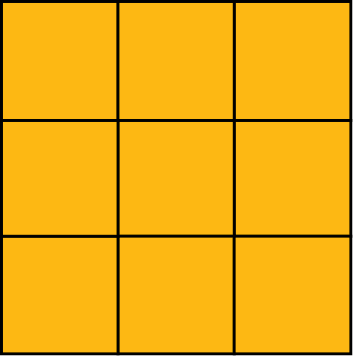  This is a tessellation because there are no gaps or overlaps. | Explains why a pattern does not show a tessellation  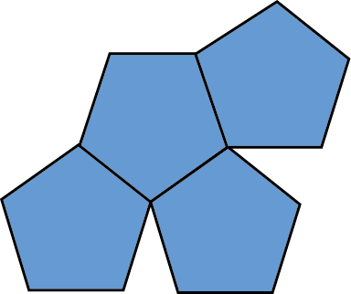  This pattern does not show a tessellation because there are gaps in it. | Draws a shape that tessellates, and constructs the tessellation  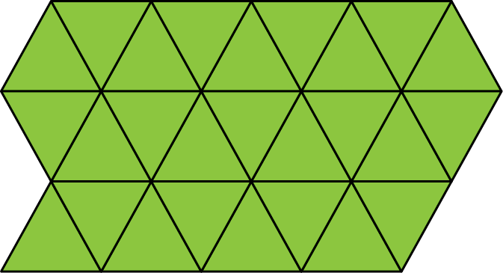 | Identifies 2 shapes that tessellate, then draws the tessellation  The square and equilateral triangle tessellate.  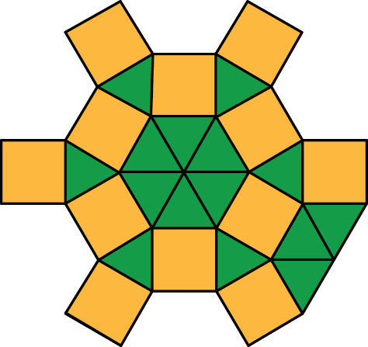
Observations/Documentation

