Why Do They Tessellate?
Geometry
Unit 1 Line Master 3a

- What is the sum of the angles in a triangle?
- For each polygon shown, draw diagonals from one vertex
to each of the other vertices.

Square Rectangle

Regular pentagon Regular hexagon

Regular octagon Regular decagon
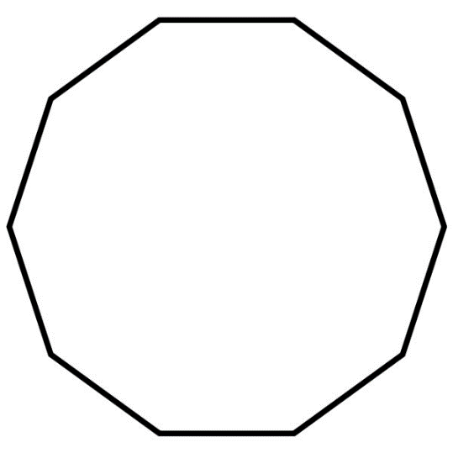
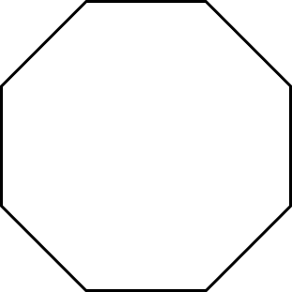

Why Do They Tessellate? (cont’d)
Geometry
Unit 1 Line Master 3b

- Complete the table.
Polygon | Number of triangles | Sum of angle measures | Measure of each angle | 360° ÷ angle measure
rectangle
square
regular pentagon
regular hexagon
regular octagon
regular decagon

Why Do They Tessellate? (cont’d)
Geometry
Unit 1 Line Master 3c

- Does a regular decagon tessellate?
Justify your answer.

- Explain why some polygons tessellate and other polygons do not.

