Determining the Probability of Events (Dependent Events)
Uses examples to explain the difference between dependent events and independent events  Dependent events: the outcome of one event affects the outcome of the other event, for example, removing a marble from a bag, and not replacing it before a second marble is taken.  Independent events: the outcome  of one event does not affect the outcome of the other event, for example, removing a marble from  a bag, then replacing it before a second marble is taken. | Identifies the sample space for two dependent events  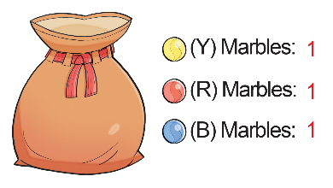  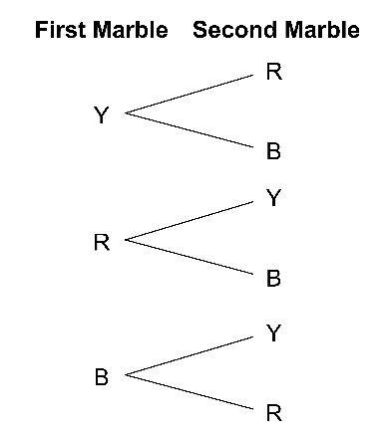  The sample space is:  Y, R; Y, B; R, Y; R, B; B, Y; B, R | Determines the probability of two dependent events using the sample space  From the sample space, the probability of removing blue and yellow marbles is:  $\frac{2}{6}$= $\frac{1}{3}$, or 0.$\overline{3}$, or 33.$\overline{3}$% | Determines the probability of two dependent events using operations  Probability of removing blue then yellow is:  $\frac{1}{3}$× $\frac{1}{2}$= $\frac{1}{6}$  Probability of removing yellow then blue is:  $\frac{1}{3}$× $\frac{1}{2}$= $\frac{1}{6}$  So, the probability of removing blue and yellow marbles is:  $\frac{1}{6}$+ $\frac{1}{6}$= $\frac{1}{3}$
Observations/Documentation

