Sample Spaces for Single Events

Data Management
Unit 2 Line Master 1

For each event, determine:
- the sample space
- the size of the sample space
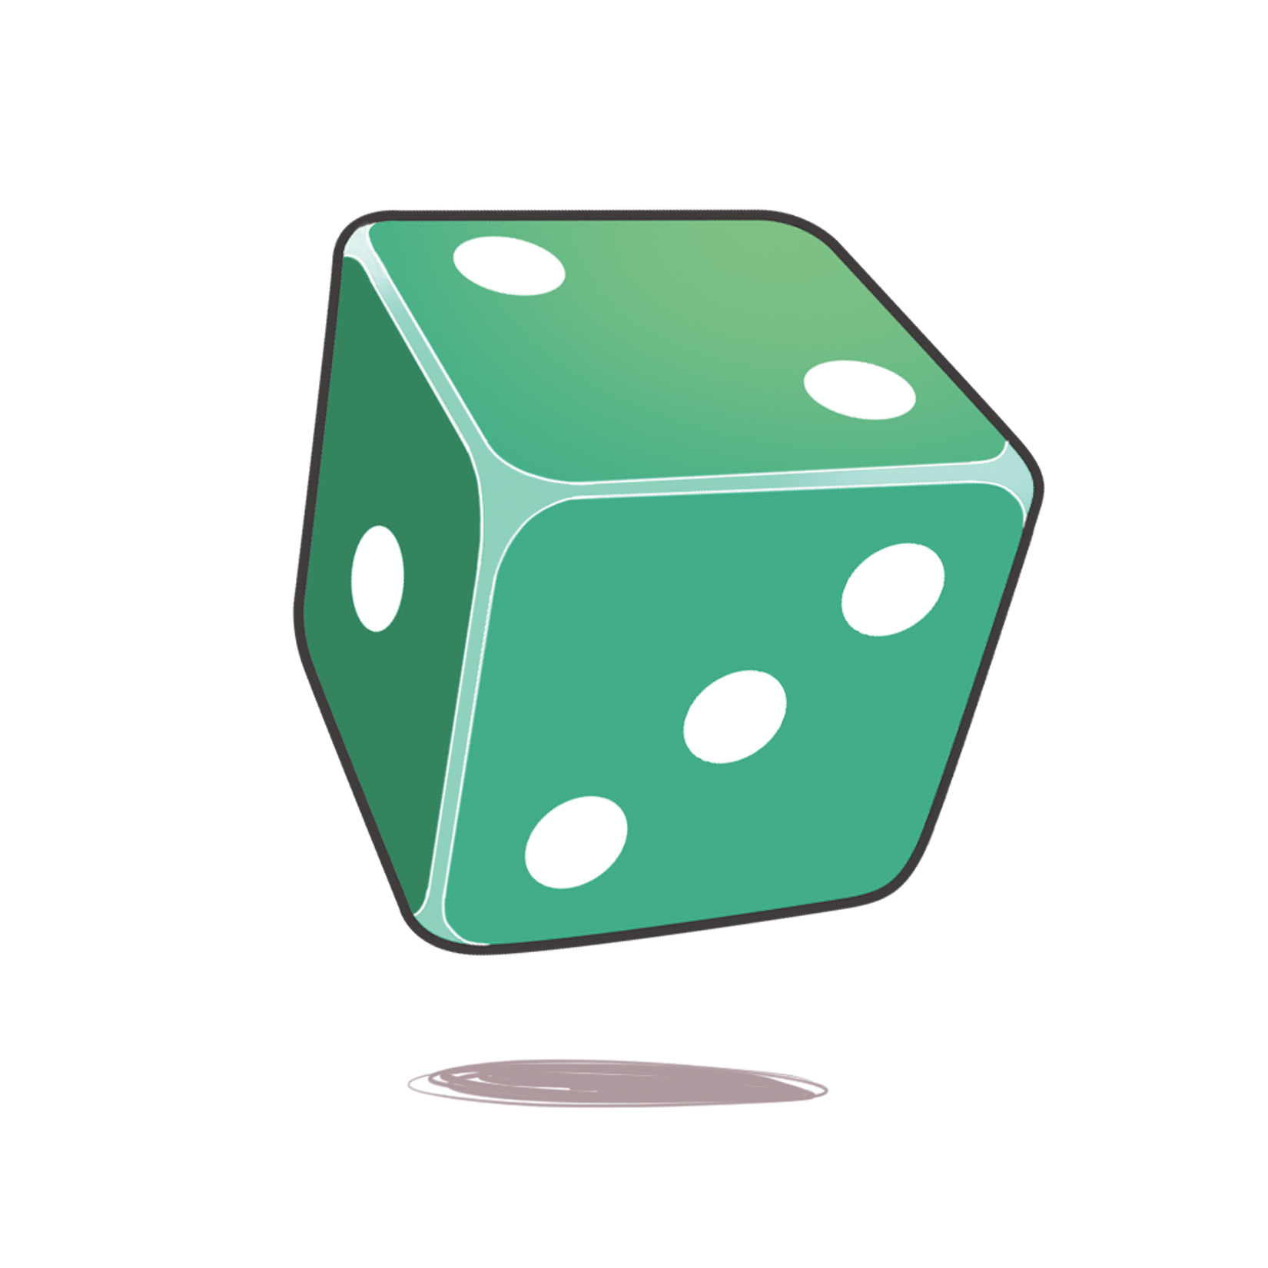
Event 1: Rolling a number cube
Sample space:

Event 2: Tossing a coin
Sample space:

Event 3: Spinning the pointer
Sample space:

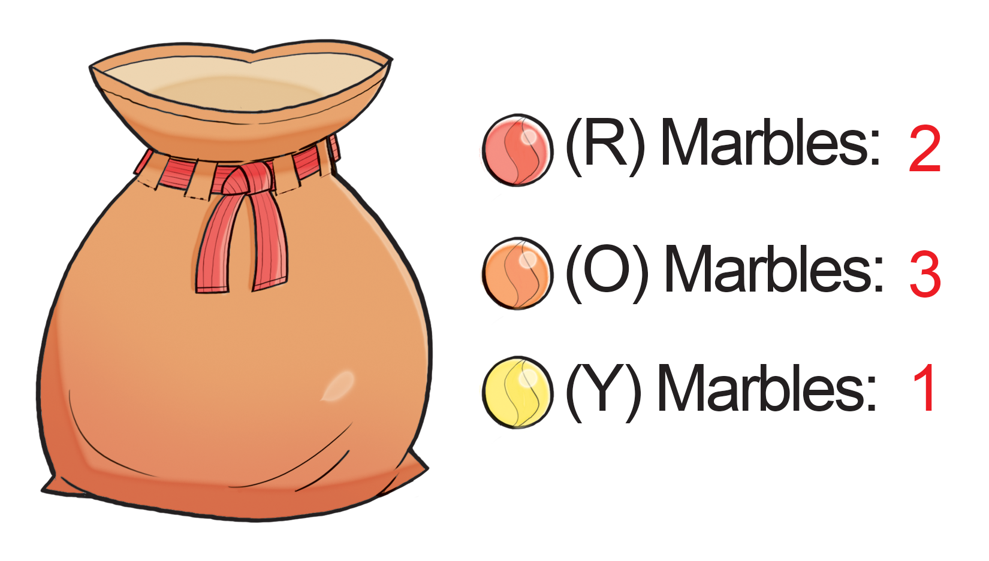
Event 4: Picking from a bag of marbles
Sample space:

