Analyzing and Critiquing Given Data
Analyzes and interprets a given graph  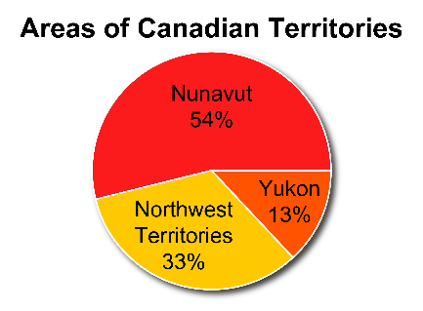  The Northwest Territories is about one-third of the total area of the territories.  Nunavut is a bit more than one-half of the total area of the territories. | Identifies the misrepresentation in a graph  Birds at a Feeder  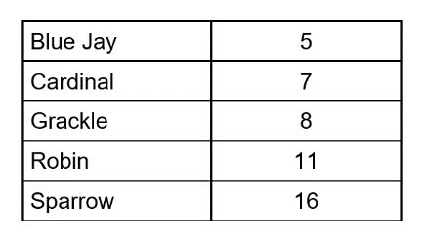  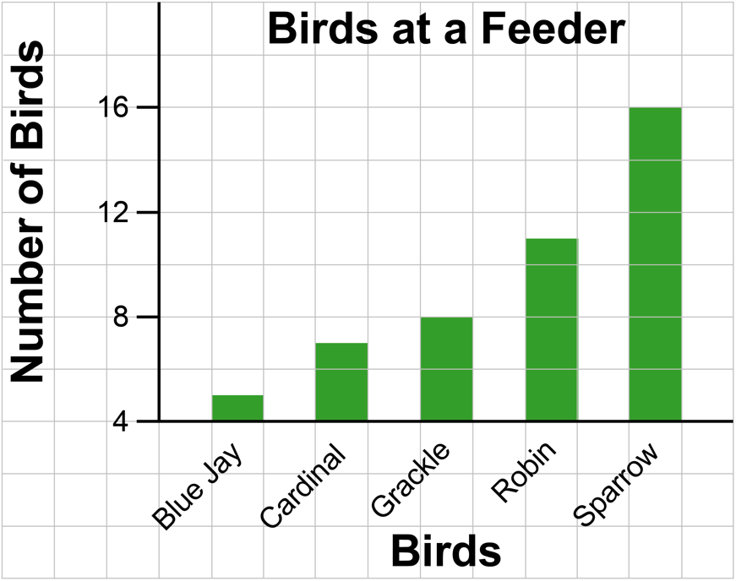  There are twice as many sparrows as grackles, but the graph appears to show that there are three times as many sparrows as grackles. | Corrects the misrepresentation in the graph  Redraw the graph so the vertical axis begins at 0.  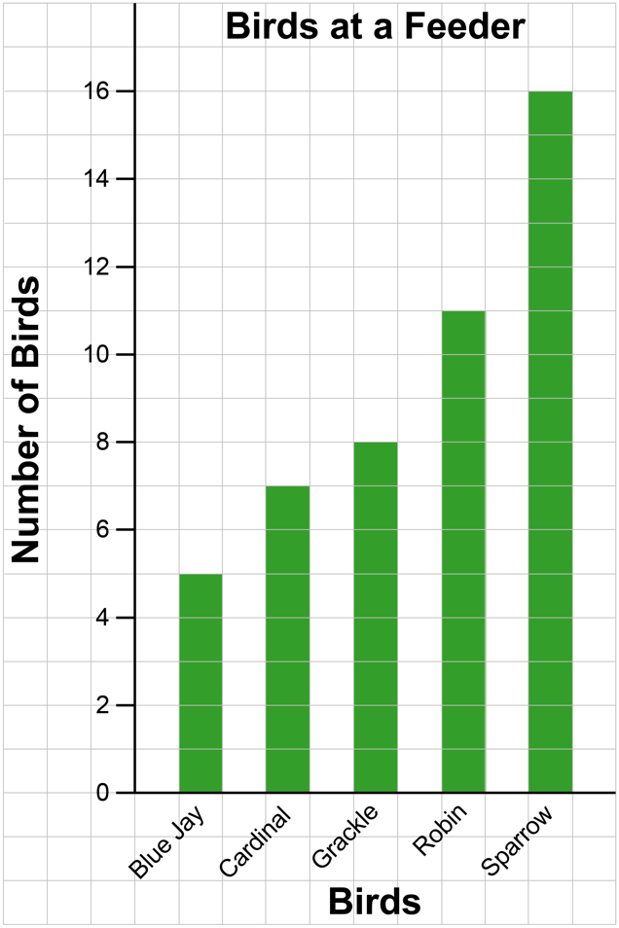 | Constructs a graph to misrepresent data, and explains the misrepresentation  Populations of some Canadian cities, to the nearest 100 000  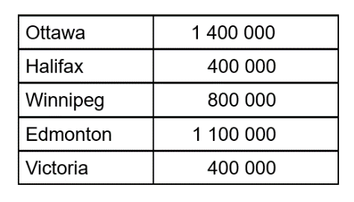  I drew a bar graph with the vertical axis beginning at 300 000.  It shows that the population of Winnipeg is 5 times the population of Halifax, instead of 2 times.  Biased graph  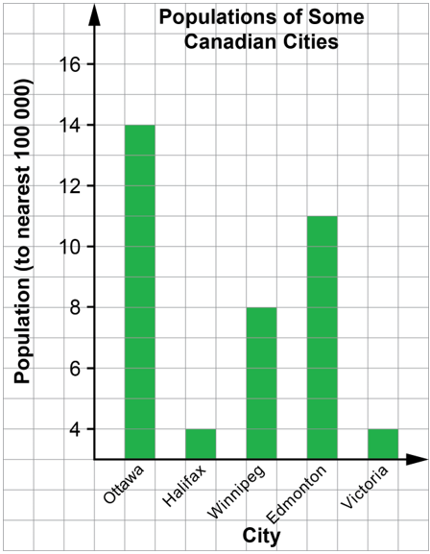

Observations/Documentation

