Presenting Data Graphically
Compares the information from different graphs for the same  data set  Bar graph  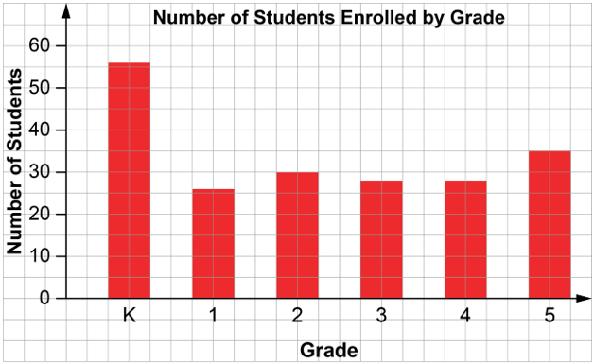  The data for the bar graph are shown as percents in this circle graph.  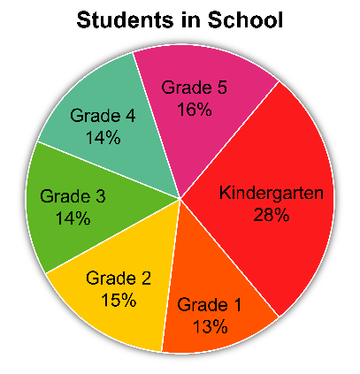  If I want to know how many students are in each grade, I would use the bar graph.  If I wanted to compare the sizes of the classes, I would use the circle graph and compare the sectors. | Uses the given data to decide on the type of graph to draw, and justifies the choice  I created a circle graph to show the results of a student census. Because the number of students is large,  I used a circle graph that shows percents to make it easier to compare the categories.  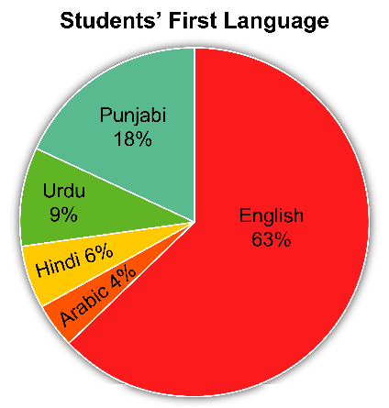 | Asks and answers questions about  a graph  Question: What fraction of the students have Punjabi as their first language?  Answer:  The sector for Punjabi is 18%, which  a little less than $\frac{1}{5}$ of the students. | Suggests an alternative graph  to display a given data set  For the students’ first language data, the data is separated into categories, so I could also draw a bar graph.

Observations/Documentation

