Determining Mean and Mode
Explains the mean and the mode of a data set  The mean and the mode are single numbers used to represent a data set.  The mean is the average of the  data values.  The mode is the value that occurs most often. | Determines the mean and mode using concrete materials  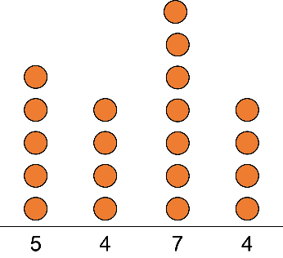  The mode is 4 because it is the number that occurs most often.  To make the stacks the same height, move 1 counter from the stack of 7 to each of the stacks of 4.  Then, there are 5 counters in each stack.  The mean is 5. | Calculates the mean and identifies the mode  Data set:  36, 42, 25, 40, 42  The mean is:  $\frac{36 + 42 + 25 + 40 + 42}{5}$  = $\frac{185}{5}$  = 37  The mean is 37.  The mode is 42. | Explains how the mean and/or mode change when the data in a set change  Data set:  36, 42, 25, 40, 42  The mean is 37.  The mode is 42.  New data set:  36, 42, 25, 40  The mean is:  $\frac{36 + 42 + 25 + 40}{4}$  = $\frac{143}{4}$  = 35.75  Now, there is no mode and the mean decreases.
Observations/Documentation

